# **General** <http://www.geeksforgeeks.org/a-complete-step-by-step-guide-for-placement-preparation-by-geeksforgeeks/>

<https://www.cs.cmu.edu/~adamchik/15-121/lectures/>

# **Algorithms** <http://www.geeksforgeeks.org/fundamentals-of-algorithms/>

## **1. Pointers**

### **Index in Data Structures**

* In Array
  + Interleaving <http://cs.stackexchange.com/questions/332/in-place-algorithm-for-interleaving-an-array>
  + Partition - think quicksort
  + Squeeze Rule - for sorted, distinct arrays, pigeonhole principle
  + with Binary Search <http://www.java2novice.com/java-search-algorithms/binary-search/>
* In String
  + Palindrome - same forwards as backwards except mid point, iterate with 2 pointers going toward the middle and make sure to cover end cases
  + KNP Pattern matching - “is there a suffix that is also a prefix in pattern already matched @ point of failure” <http://www.geeksforgeeks.org/searching-for-patterns-set-2-kmp-algorithm/>
  + Substring Windows - designing algorithms 18.8, 18.9
    - <https://discuss.leetcode.com/topic/30941/here-is-a-10-line-template-that-can-solve-most-substring-problems>
    - <https://discuss.leetcode.com/topic/21143/java-solution-using-two-pointers-hashmap/3>
    - <http://www.geeksforgeeks.org/find-the-smallest-window-in-a-string-containing-all-characters-of-another-string/>
* In Linked List
  + Walker and Runner Node - one node iterates at normal pace, other node iterates at 2x or 2+1 or whatever pace
    - <http://www.codescream.com/ContentDisplay?targetContent=LinkedListCycle>

* + Dummy Node - linked list type where a dummy node sits at front, useful for inserting/removing items because you don’t have to handle head=null case
    - <http://www.cs.uwm.edu/faculty/boyland/classes-archive/fa15.cs351/www/linked-list-variations.html>

### **Applications**

* Remove Duplicate - Can use HashSets or if it’s in place iterate through twice, once to count duplicates then 2nd time with 2 pointers one from start other from end, replacing any duplicates.
  + <http://www.geeksforgeeks.org/remove-duplicates-from-a-sorted-linked-list/>
  + <http://www.geeksforgeeks.org/remove-duplicates-from-an-unsorted-linked-list/>
* Make Partition - pointers can be used to make arbitrary partitions by storing index (ie quicksort)
* Do swap - just create a tmp variable to store 1 of the swapped values
* Find element - you can binary search, iterate search or recurse thru pointers

## **2. Sort and Search**

### **Sort**

* Selection Sort - O(n^2): iterate from start to finish, each time scanning array for next smallest and replacing index, literally never use it.
* Insertion Sort - O(n^2): iterate from start to finish, keep left side sorted and insert each new element into its correct location.. I guess you could use this on almost sorted arrays
* Bubble Sort - O(n^2): iterate through array and compare index to the one right of it, if right<index then swap them and compare new_index to left recursively till left side of array is sorted
* Merge Sort - O(nlogn): recursively call merge to split array into 2 subarrays until you have size 1 arrays. Then recursively merge each sub arrays into sorted arrays by comparing left[0] to right[0] and inserting the smaller element back in place. Use this when memory isn’t an issue, when dealing with small arrays or when you think you have a worst case scenario for quicksort.
  + External merge sort for sorting array > memory: first sort each memory sized chunk using an in-place sort (quicksort), then use the “merge” part of merge sort to compare ordered sub-chunks to one another

<http://www.ashishsharma.me/2011/08/external-merge-sort.html>

* Quick Sort - O(nlogn) avg, O(n^2) worst: pick center index as pivot then iterate both sides finding elements smaller than pivot and replacing them with elements greater than pivot so left of pivot is smaller and right is > pivot. Call recursively on both sides. Use when you have to sort in place, large arrays or when you think average case is likely.
  + <http://www.java2novice.com/java-sorting-algorithms/quick-sort/>
* Count Sort - O(n) special case sort for when your keys are between a specific range and distributed somewhat evenly, perform a type of hashing to place each value in its intended position
  + <http://www.geeksforgeeks.org/counting-sort/>
* Radix/Bucket Sort - O(n) special case sort for doubles. Create buckets for intervals of doubles and connect them to linked lists then for each one insert a[i] into a[number of buckets*a[i]]
  + <http://www.geeksforgeeks.org/bucket-sort-2/>

### **Search**

* Binary Search <http://www.java2novice.com/java-search-algorithms/binary-search/>
* Breadth First Search <http://www.geeksforgeeks.org/breadth-first-traversal-for-a-graph/>
* Depth First Search <http://www.geeksforgeeks.org/depth-first-traversal-for-a-graph/>
  + DFS vs BFS <http://www.geeksforgeeks.org/bfs-vs-dfs-binary-tree/>
* Union Find - can be used to check for cycles in undirected graphs.. Also useful for keeping track of what nodes can be reached from where (ie for path finding)
  + <http://www.geeksforgeeks.org/union-find/>

## **3. From Recursion to Dynamic Programming**

### **Recursion** <http://www.geeksforgeeks.org/tag/recursion/>

### **Greedy Algorithms** - always make the currently optimal choice

<http://www.geeksforgeeks.org/tag/greedy-algorithm/>

### **Divide and Conquer** - split problem into subproblems, and build up to solution <http://www.geeksforgeeks.org/tag/divide-and-conquer/>

* In array - Merge sort, quicksort, closest pair of points, “paint” coloring, binary search, combinations/permutations, “what pairs of elements add to X”?
  + <https://discuss.leetcode.com/topic/426/how-to-solve-maximum-subarray-by-using-the-divide-and-conquer-approach/2>
* In tree - searching in BST, tree construction, dividing an image
* In linked list - could be used for permutations or combinations of list
  + <http://www.geeksforgeeks.org/merge-sort-for-linked-list/>

### **Backtracking** - used in finding min paths for trees and graphs or dual pointer array/linked list traversal <http://www.geeksforgeeks.org/tag/backtracking/>

* Combination - order isn’t important
  + <http://www.programcreek.com/2014/03/leetcode-combinations-java/>
  + <http://www.mytechinterviews.com/combinations-of-a-string>
  + <http://www.programcreek.com/2014/02/leetcode-combination-sum-java/>
* Permutation - order matters, you have n! Permutations of n objects
  + <http://javarevisited.blogspot.com/2015/08/how-to-find-all-permutations-of-string-java-example.html>
  + <http://www.programcreek.com/2013/02/leetcode-permutations-java/>
* N Queen <http://www.geeksforgeeks.org/backtracking-set-3-n-queen-problem/>

### **Dynamic Programming**

### Use overlapping subproblems to cache already done work and optimize solution. These can commonly be solved using recursion then made more efficient by applying DP.. “THINK TOP-DOWN/RECURSIVELY, IMPLEMENT BOTTOM UP” Memoization is caching results top-down, Tabulation is caching bottom-up.

DP problems have 2 properties:

1. Overlapping Subproblems - same subproblems are solved repeatedly
2. Optimal Substructure - optimal solution for problem is found by using optimal solutions to its subproblems

### <http://www.geeksforgeeks.org/tag/dynamic-programming/>

<https://www.topcoder.com/community/data-science/data-science-tutorials/dynamic-programming-from-novice-to-advanced/>

* Matrix DP - used for path finding, shortest path from A to B, longest path present, multiplication of matrixes
* (LIS) Longest Increasing Subsequence:
  + Naive: sort the array to a temp T, find longest common subsequence between array and T. O(n^2).. Can be done in nLog(n).
  + Instead iterate thru, add elements > head and binary search elements < into their correct position in the increasingSub[]

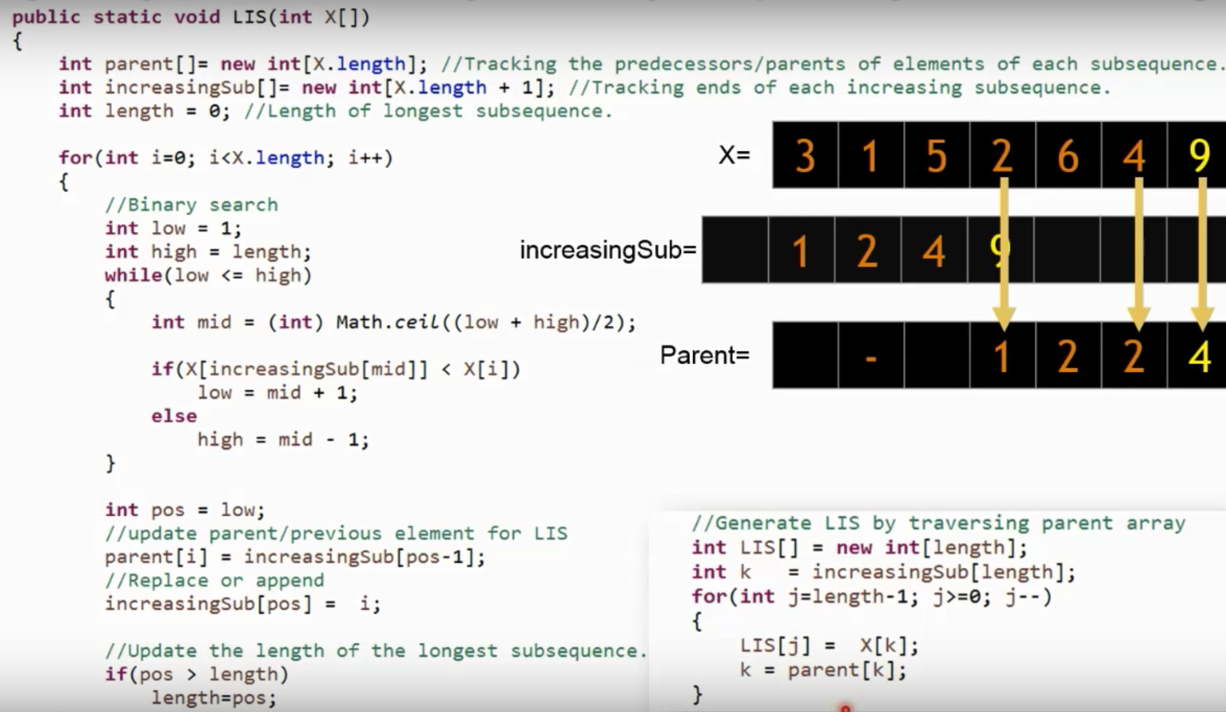

LIS (non-dynamic but nlog(n) ):

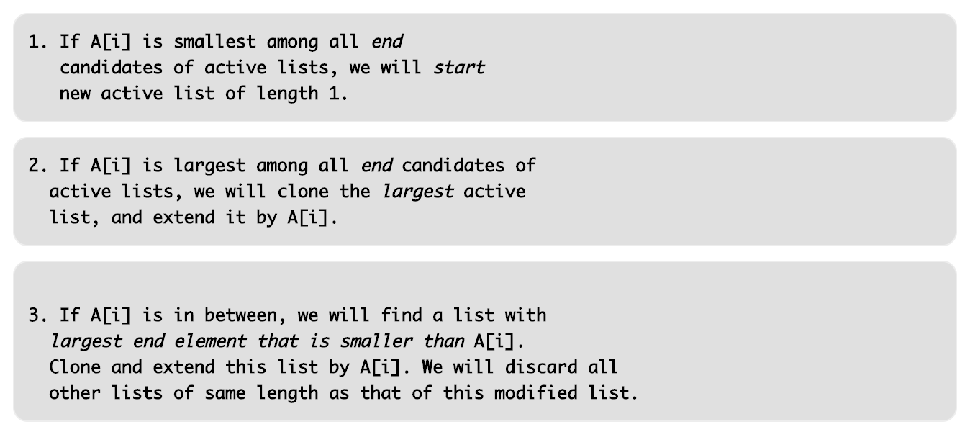

<https://www.youtube.com/watch?v=S9oUiVYEq7E>

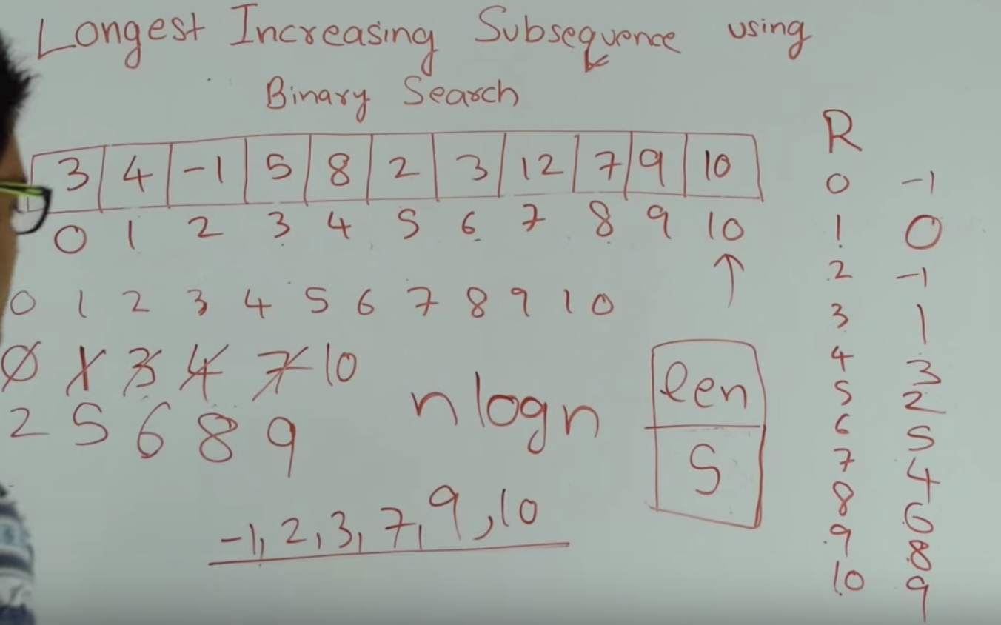

* One Sequence DP - longest repeating sequence
  + <http://www.geeksforgeeks.org/longest-repeating-subsequence/>
* (LCS) Two Sequence DP - longest common sequence, sequence alignment
  + <https://www.youtube.com/watch?v=fXfLU0QOfj8>
  + Similar to backpack problem, if last char matches call recursively on -1 char subarrays with +1 L; if it doesnt match = max( rec(x,y-1) , rec(x-1,y) ).. Calling this naively results in O(n^2)
  + Instead construct bottom-up Matrix to save recursive calls if X[m] = Y[n] then M[m][n] = M[m-1][n-1] + 1, else its max(M[m-1][n] , M[m][n-1]).. M[n][m] represents the length of the longest subsequence from X[0-n] and Y[0-m]
  + Once we construct the matrix we start at right bottom and move diagonally if it was a match or up/left if it was from a max call

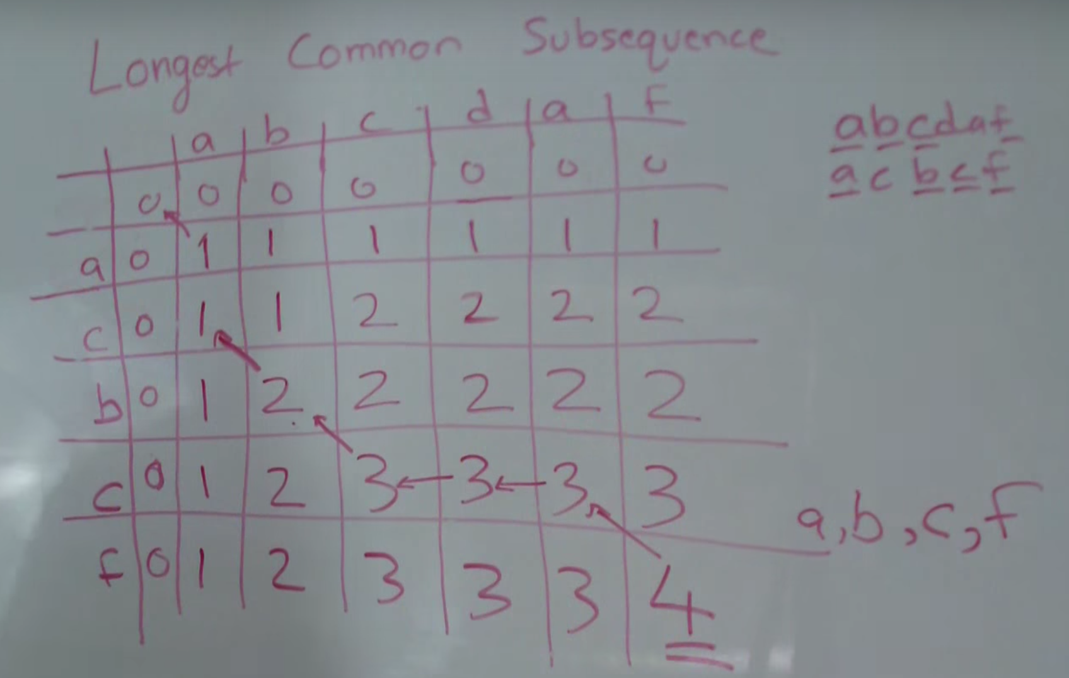

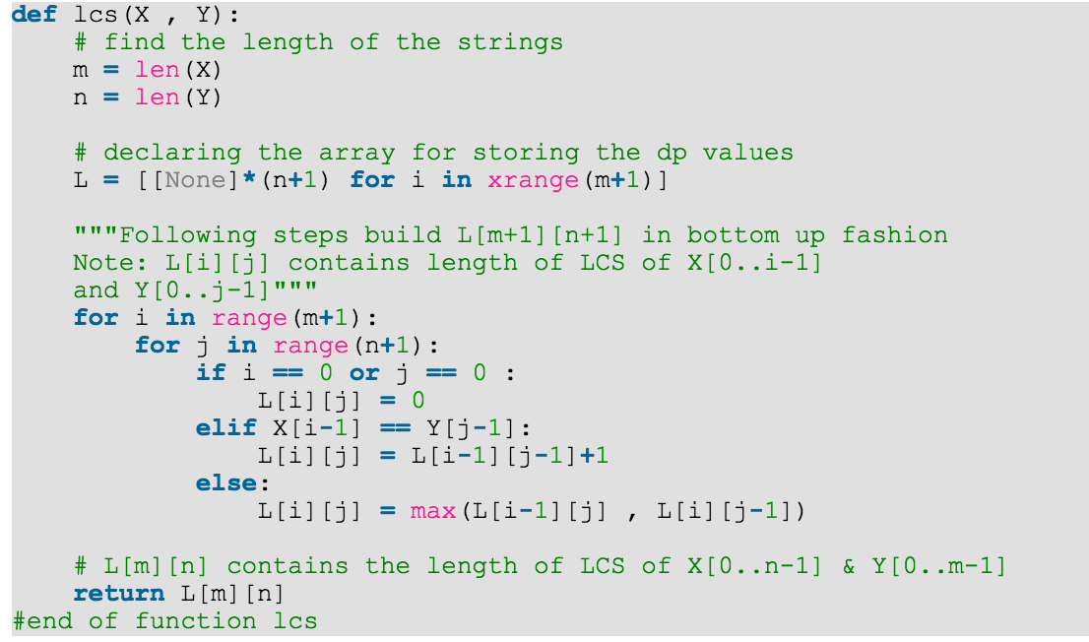

* Backpack/Knapsack - Given weights and values of ‘n’ items, put these items in a backpack with capacity W to get the maximum total value in the backpack.
  + <http://www.geeksforgeeks.org/dynamic-programming-set-10-0-1-knapsack-problem/>
  + Simple solution:
    - Consider all subsets of all items and calculate total weight of all
    - Consider only subsets whose total weight < W
    - From those subsets, pick the subset with the max possible value
  + Dynamic:
    - Optimal substructure: to consider all subsets of items, there are 2 cases for each item - either it’s included in the optimal subset or not
    - Max val obtained is either: (you call max on the 2 and go with the better one)
      * Max value from n-1 items and W weight (excluding nth item)
      * Value of nth item + max value from n-1 items and W - weight of nth (including nth)
    - Construct K[n][W] lookup table in a bottom-up manner to avoid repeated recursive calls

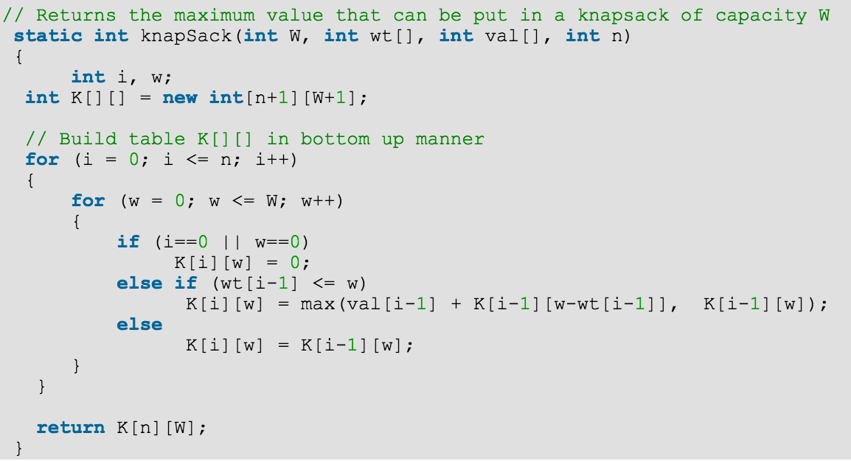

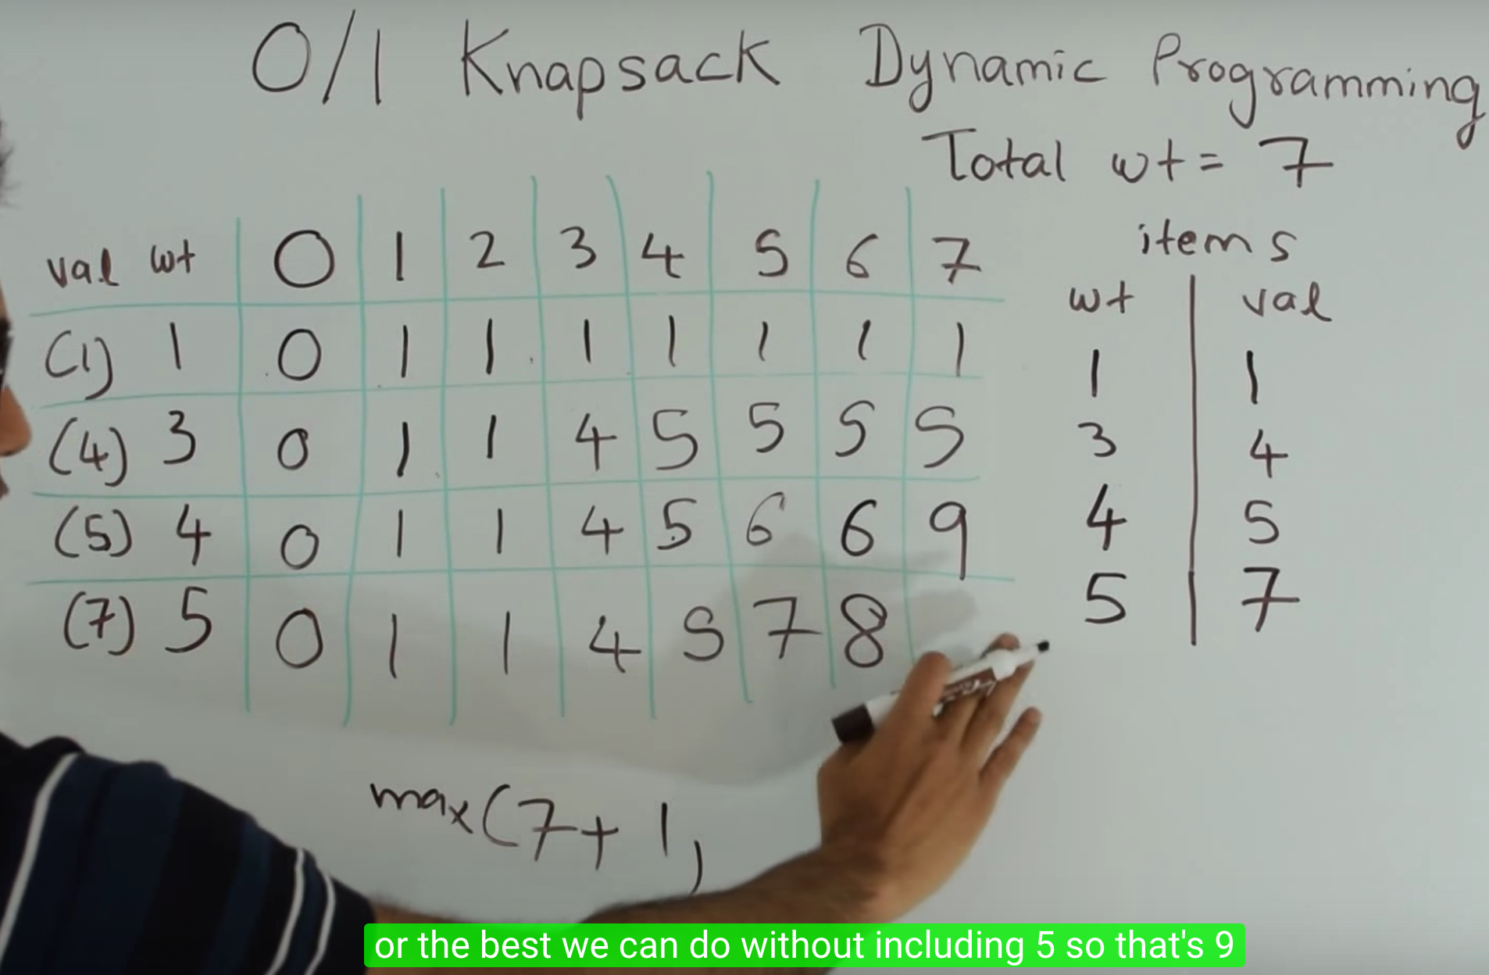

Coin Change: given a total and set of coins find min # of coins to make that total. Can use coins multiple times

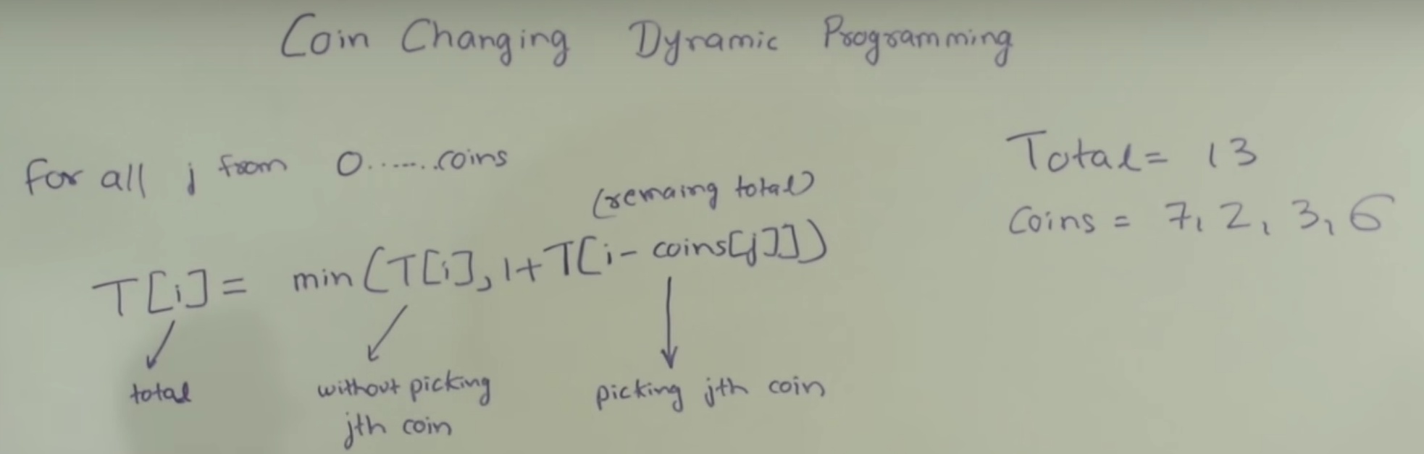

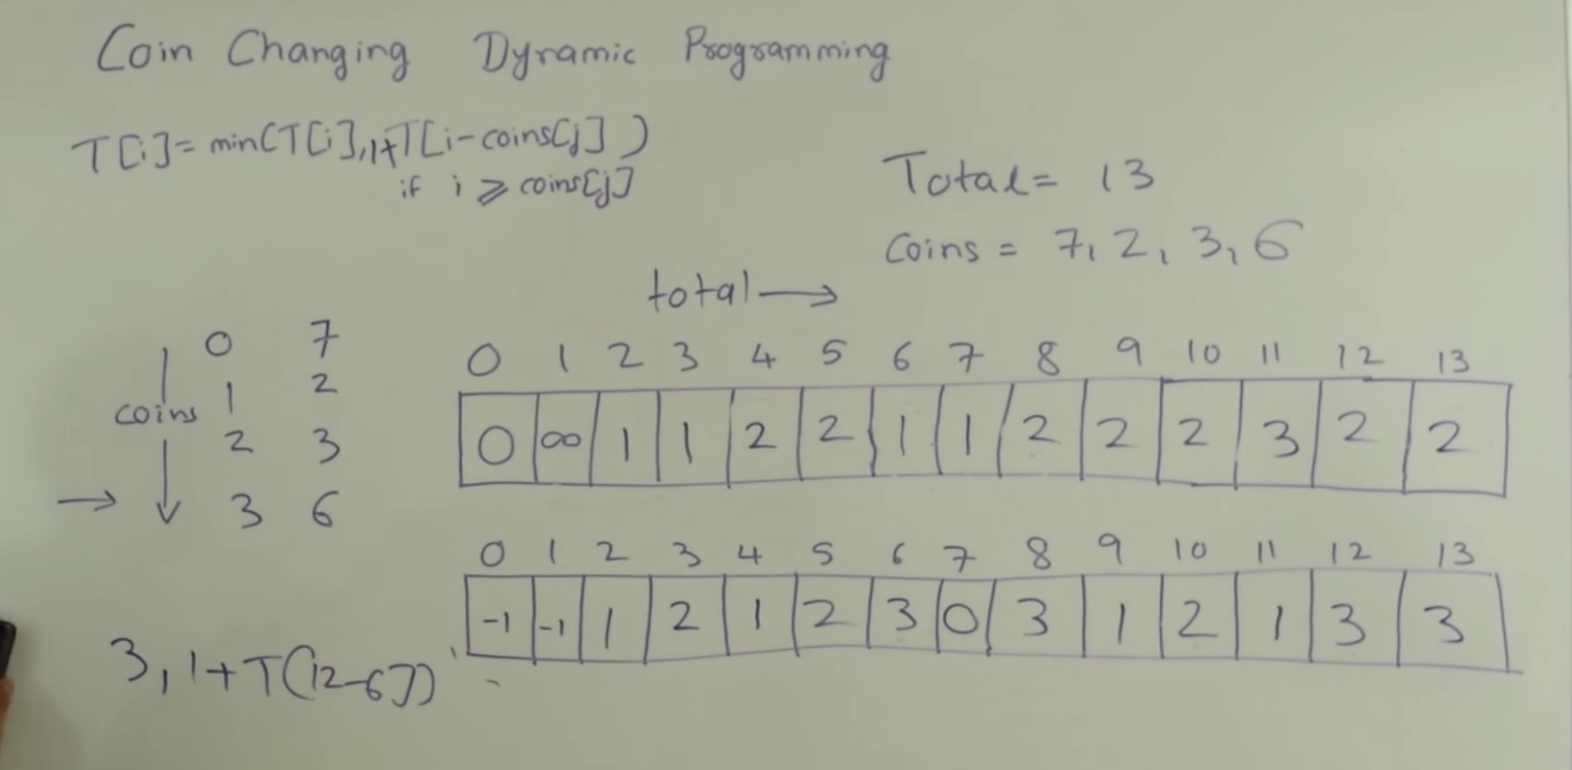

-first array is the # of coins to get that value, second array keeps track of index of coin you picked to get that value

Optimal BST given keys and frequencies where the search time = frequency*level its at:

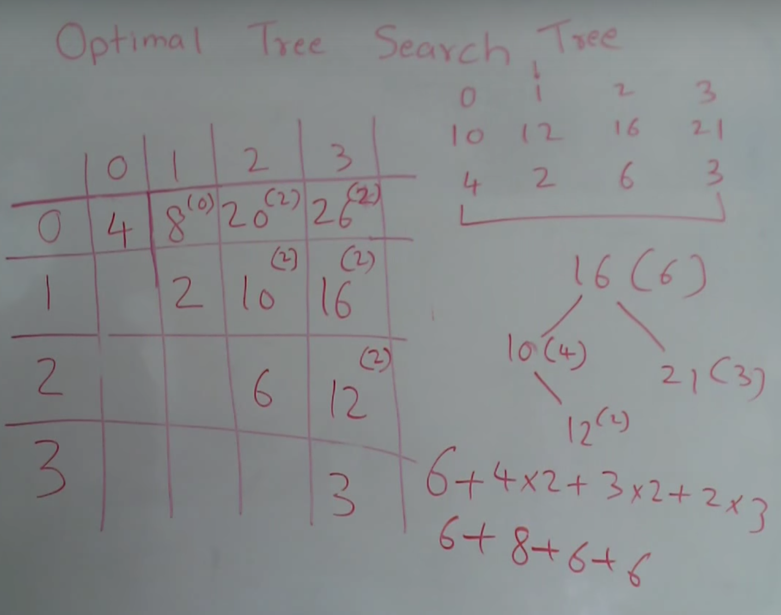

-how to calculate M[3][3]:

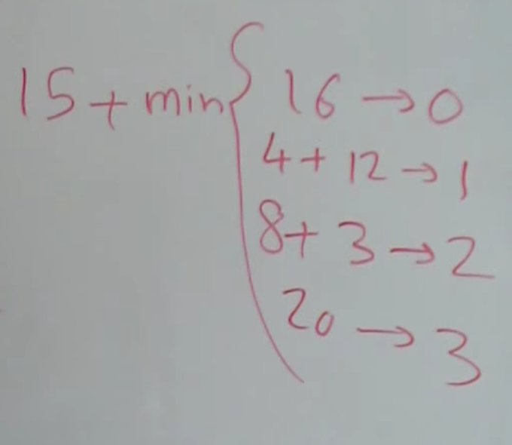

**Minimum Edit distance**

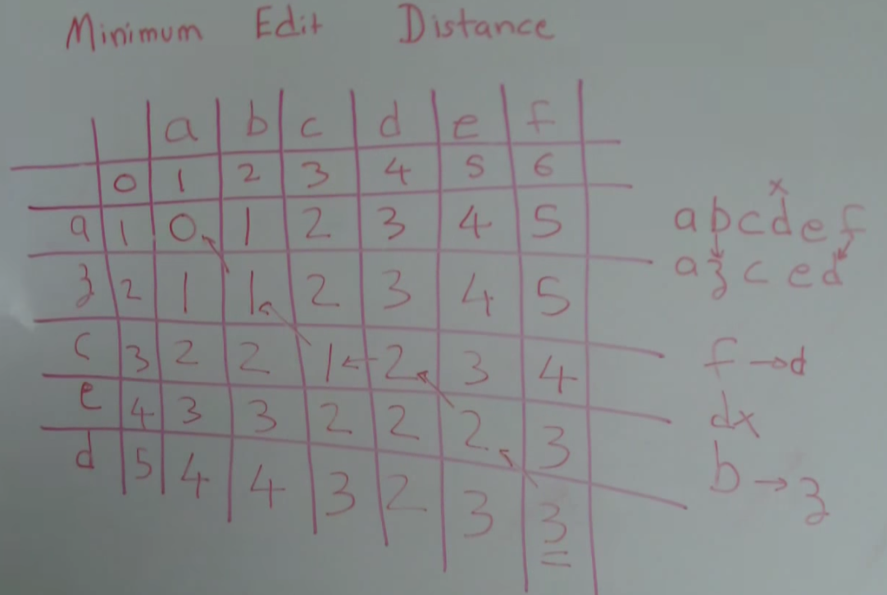

-if str1[i] != str2[j] then M[i][j] = min( M[i-1][j], M[i][j-1], M[i-1][j-1] ) + 1; else if str1[i] == str2[j] then M[i][j] = M[i-1][j-1]

Longest Palindromatic Subsequence:

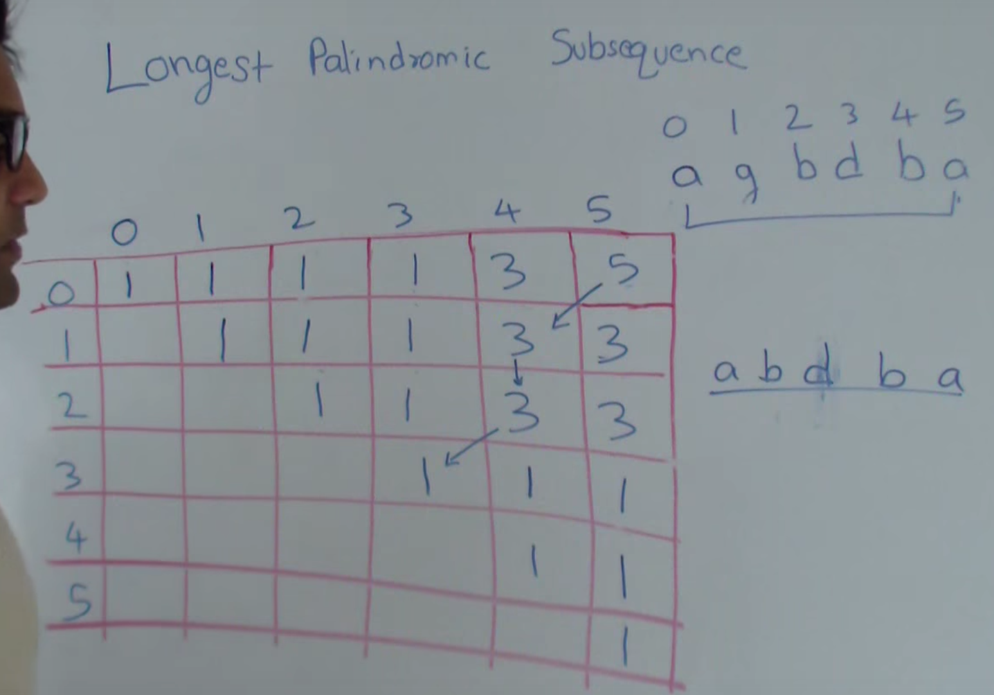

- M[i][j] = length of longest palindromic subsequence starting at i and ending at j

- start by filling out diagonal (length 1 subsequences) then move on to length 2 etc..

-if str1[i] != str2[j] then M[i][j] = max( M[i+1][j] , M[i][j-1] ); else = 2+ max( M[i+1][j] , M[i][j-1] );

**Box Stacking:** you get unlimited boxes and can rotate them. Length and width of stacked box must be < previous box

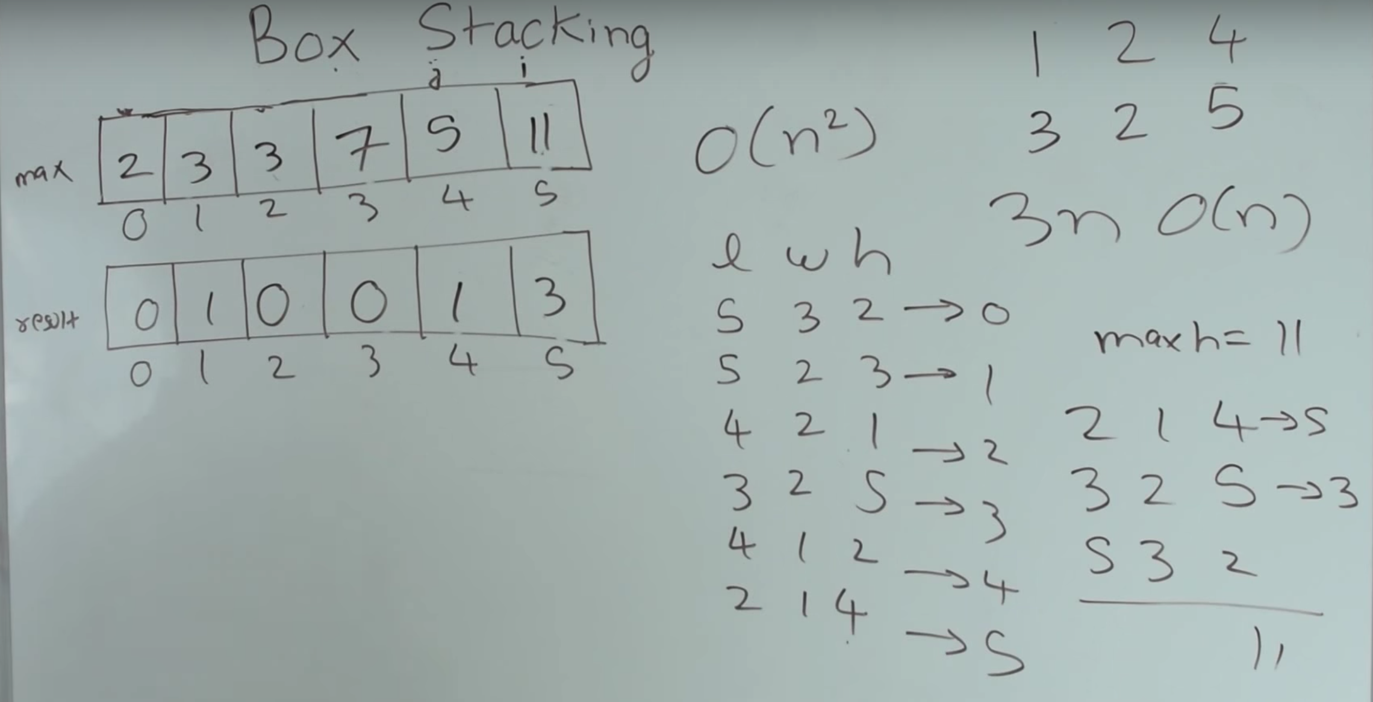

-use input boxes to create array of all possible boxes with rotations, sort based on base area (L * W). Create array # of boxes and follow method similar to longest increasing subsequence

<https://github.com/mission-peace/interview/blob/master/src/com/interview/dynamic/BoxStacking.java>

Cutting Rod for Profit:

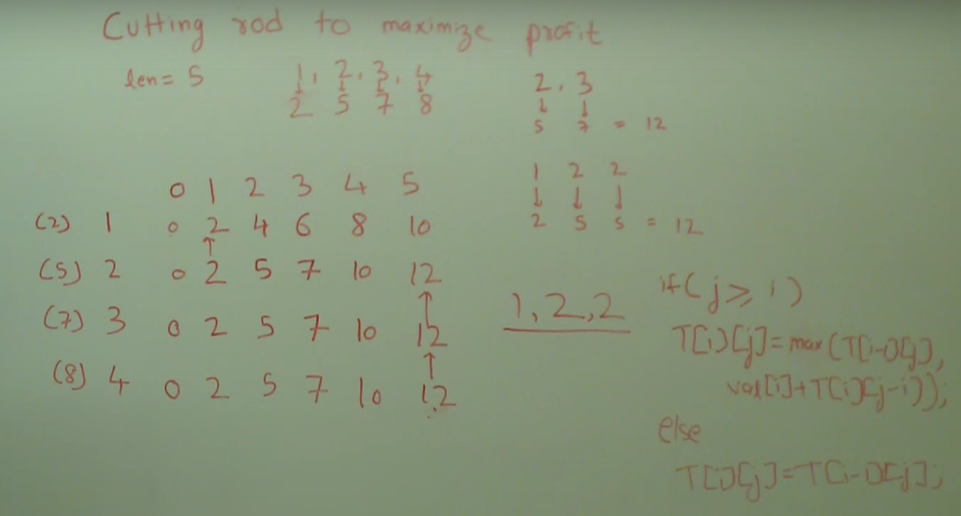

Egg Dropping: given a number of eggs and floors whats the worst case # of drops to find the highest nonbreaking floor

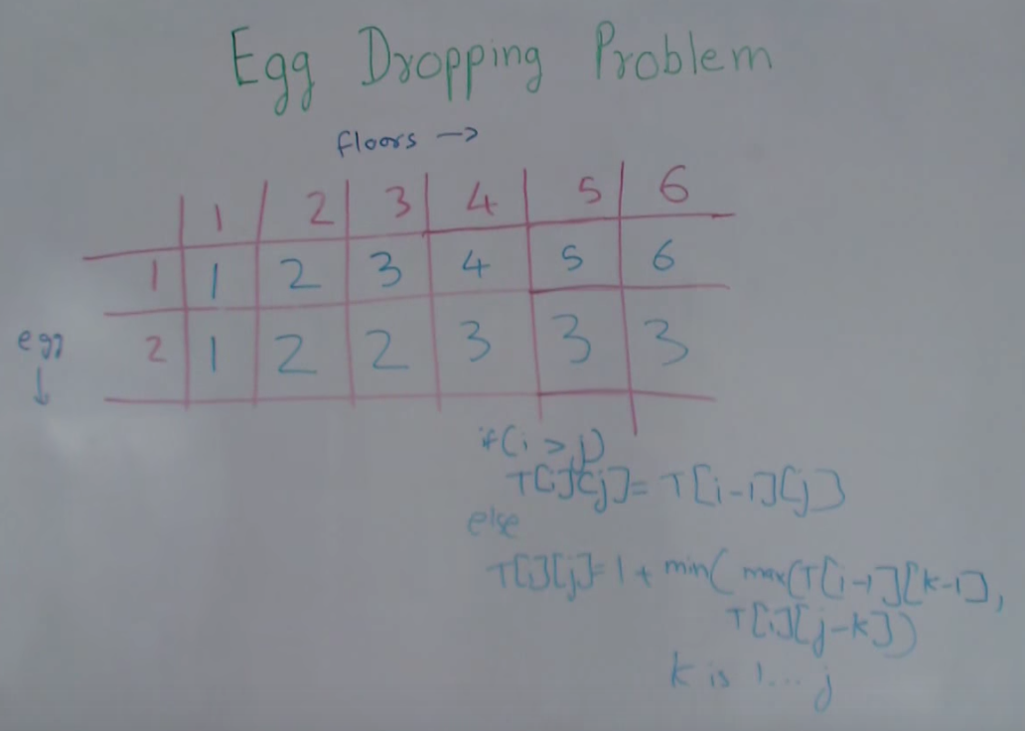

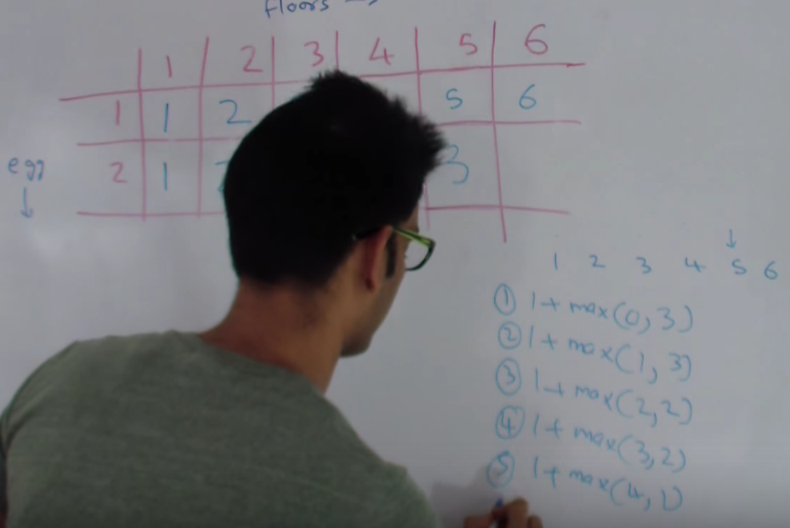

Wildcard matching (regex):

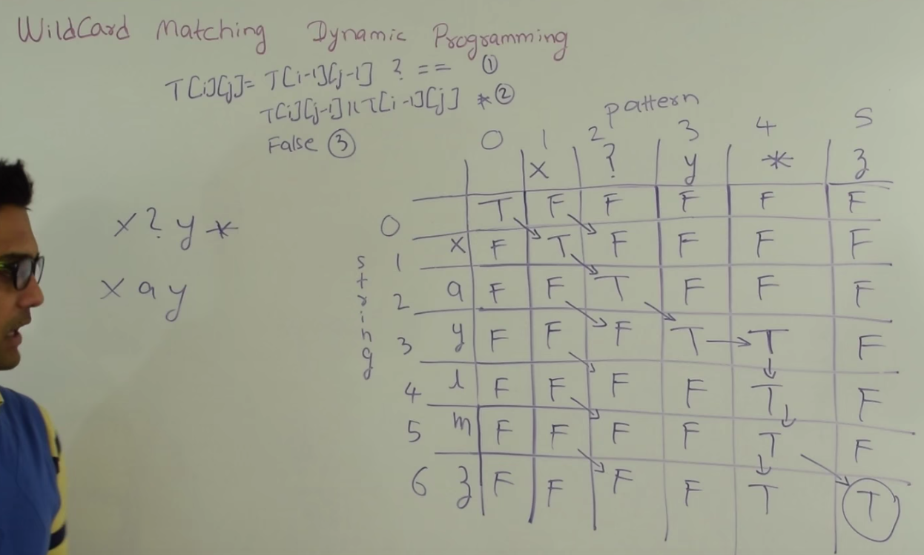

-could use a helper method to concat multiple *’s (or *’s followed by ?’s) into a single *

Maximum sum sub-rectangular submatrix (kadane’s algorithm): similar to maximum size rectangle of 1’s in 1/0 matrix

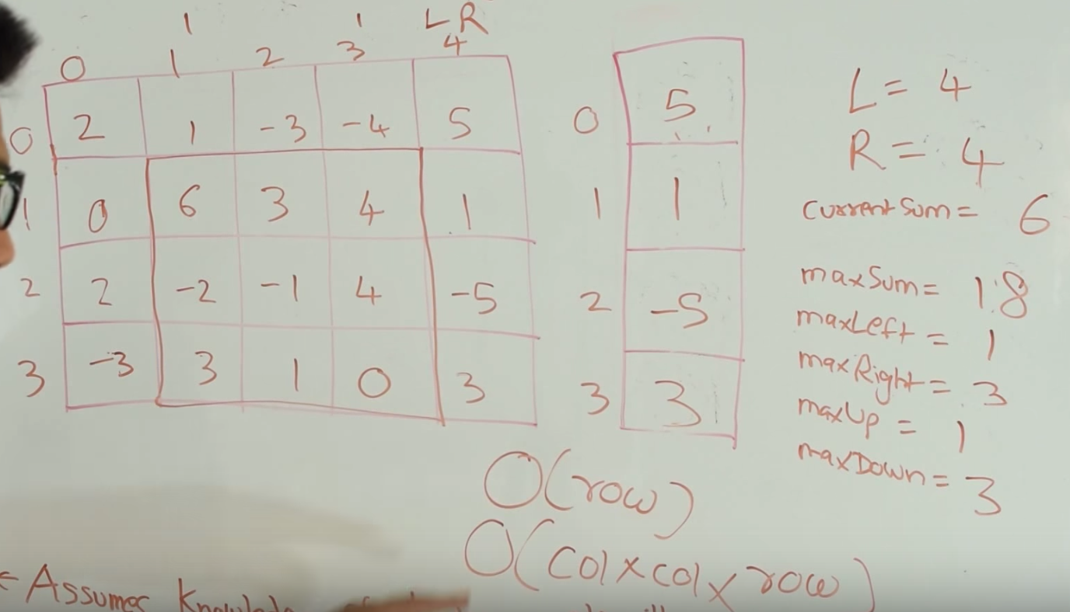

-uses Kadane’s algorithm <http://www.geeksforgeeks.org/largest-sum-contiguous-subarray/>

-you iterate each column keeping track with Right and use Kadane’s to find each max. Keep track of Left/Right/MaxUp/MaxDown + max, but when you move right you add the left col to the new right col

-once you pass through all col’s, increment Left by 1 and start right off

Text Justification: how to space an array of words so theres x characters on each line and to minimalize space padding at the end of each line

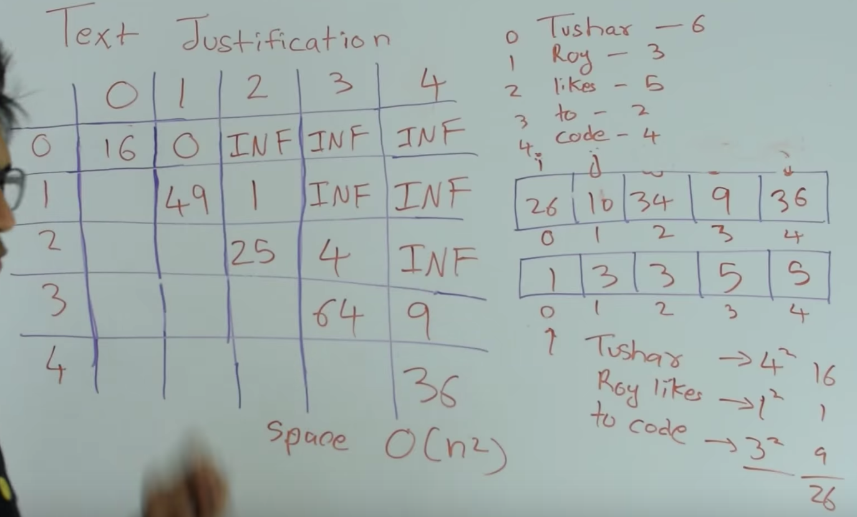

-square the number of spaces at the end to ensure balance

Job Scheduling: have to schedule jobs that don’t overlap in order to make max profit

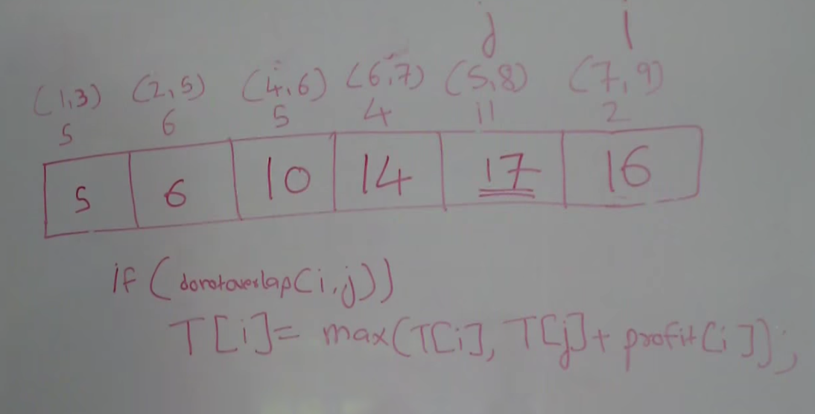

-iterate i through the array of jobs, for each i iterate j from 0 to i-1 and check if job[i] overlaps with job[j]

Matrix Chain Multiplication

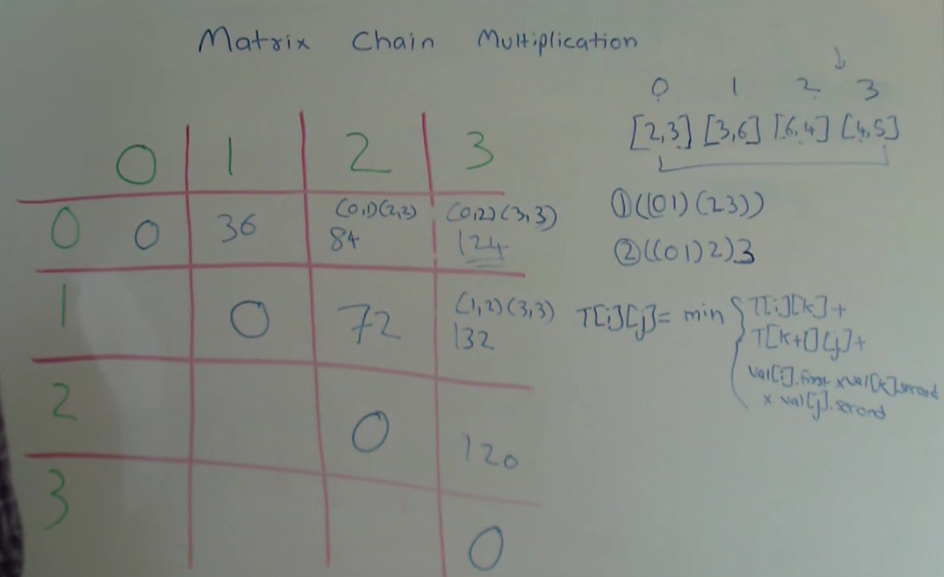

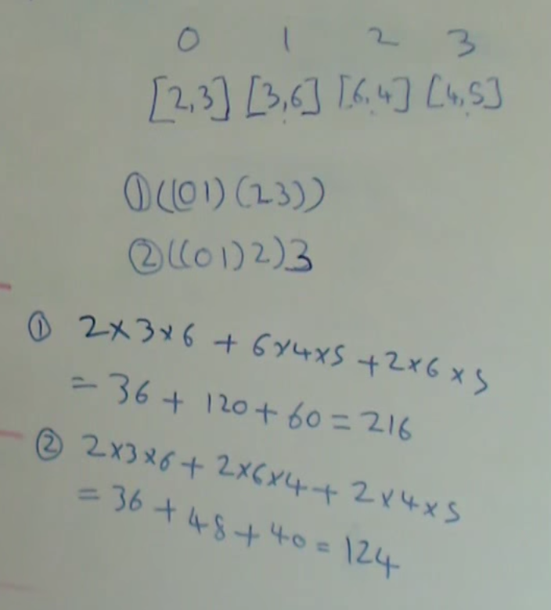

-the input values are the dimensions of each matrix and the table is the number of computations. M[1][2] denotes the smallest number of computations done to multiply matrixes Input[1-2] = [3,6]*[6,4] = 6*4*3 = 72; When multiplying 2 matrixes you get cost by multiplying row1 * col1 * col2. **Complexity = O(n^3)**

[Edit Distance](http://www.geeksforgeeks.org/dynamic-programming-set-5-edit-distance/)

[Minimum Partition](http://www.geeksforgeeks.org/partition-a-set-into-two-subsets-such-that-the-difference-of-subset-sums-is-minimum/)

[Ways to Cover a Distance](http://www.geeksforgeeks.org/count-number-of-ways-to-cover-a-distance/)

[Longest Path In Matrix](http://www.geeksforgeeks.org/find-the-longest-path-in-a-matrix-with-given-constraints/)

[Subset Sum Problem](http://www.geeksforgeeks.org/dynamic-programming-subset-sum-problem/) - given a set and a total, is there a subset that adds up to the total- -fds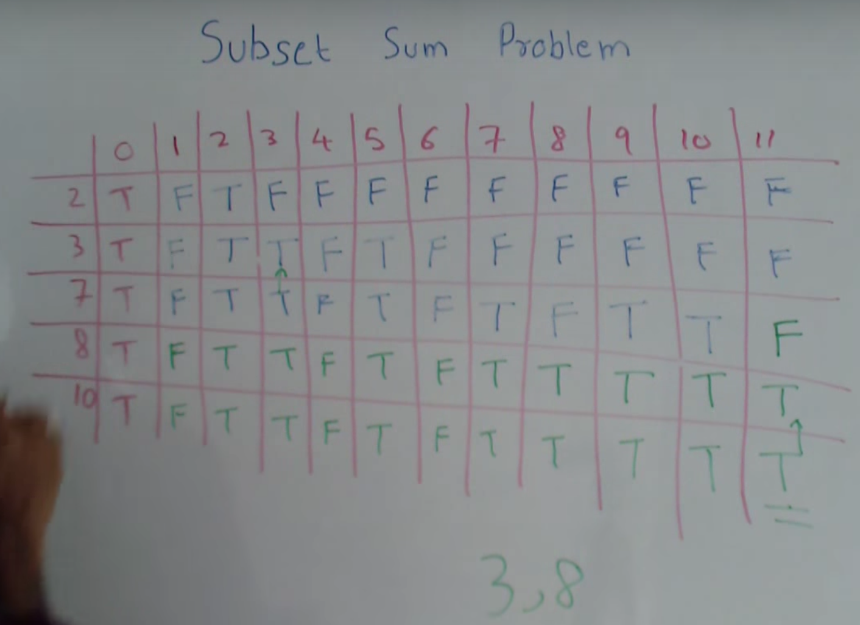

-total is 11 in the example

[Optimal Strategy for a Game](http://www.geeksforgeeks.org/dynamic-programming-set-31-optimal-strategy-for-a-game/)

[Assembly Line Scheduling](http://www.geeksforgeeks.org/dynamic-programming-set-34-assembly-line-scheduling/)

Coin Problem <http://www.geeksforgeeks.org/dynamic-programming-set-7-coin-change/>

## **4. Math**

### **Math**

* Combinatorics and probability
* Polynomial coefficients
* Greatest Common Division <http://www.vogella.com/tutorials/JavaAlgorithmsEuclid/article.html>
* Least Common Multiple <http://www.guideforschool.com/1930240-program-to-find-the-lcm-of-two-numbers-method-2/>
* Elementary Arithmetic Operation with Bitwise <https://bytes.com/topic/c/answers/859191-all-arithmatic-operations-using-bitwise-operators-only>
* Binary, octonary and 10-ary - how they’re calculated, how to convert
  + http://stackoverflow.com/questions/16008685/base-10-to-base-2-8-16-conversion-in-java
* Power and square root (Divide and Conquer)
  + <http://www.geeksforgeeks.org/write-a-c-program-to-calculate-powxn/>
  + <http://www.geeksforgeeks.org/square-root-of-an-integer/>

### **Math Algorithms**

[Primality Test | Set 1 (Introduction and School Method)](http://www.geeksforgeeks.org/primality-test-set-1-introduction-and-school-method/)

[Primality Test | Set 2 (Fermat Method)](http://www.geeksforgeeks.org/primality-test-set-2-fermet-method/)

[Primality Test | Set 3 (Miller–Rabin)](http://www.geeksforgeeks.org/primality-test-set-3-miller-rabin/)

[Sieve of Eratosthenes](http://www.geeksforgeeks.org/sieve-of-eratosthenes/)

[Segmented Sieve](http://www.geeksforgeeks.org/segmented-sieve/)

[Wilson’s Theorem](http://www.geeksforgeeks.org/wilsons-theorem/)

[Prime Factorisation](http://www.geeksforgeeks.org/print-all-prime-factors-of-a-given-number/)

[Pollard’s rho algorithm](http://www.geeksforgeeks.org/pollards-rho-algorithm-prime-factorization/)

### **Bitwise Manipulation**

### <http://www.geeksforgeeks.org/category/bit-magic/>

<https://graphics.stanford.edu/~seander/bithacks.html>

<http://aggregate.org/MAGIC/>

* OR's Magic - used for bitmasks and quick comparisons
* Left or Right Shifting - used for multiplying/dividing by 2^n
* Left shift: [variable]<<[number of places], multiplies by 2^[number of places], pads the right with 0's
* Right shift: [variable]>>[number of places], divides by 2^[number of places], pads left with 0's. May cause losses in precision with unsigned ints ie 5>>1 = 3
* AND: [variable]&[variable], takes the logical AND of each aligning bit that is 1&1=1 and 0&0=1, but 1&0 or 0&1 both = 0.
* OR: [variable]|[variable], takes the logical OR of each aligning bit, so 1|0 = 0|1 = 1|1 = 1 and 0|0 = 0.
* NOT: ~[variable], this flips every bit
* XOR: [variable]^[variable], takes the logical XOR of each aligning bit - returns 1 if 1 or the other is a 1, but a 0 if both are 1's or both are 0s.. apparently XOR is the most useful
* ADDITION/SUBTRACTION: work the same way
* MULTIPLICATION/DIVISION: simply shift to the closest power of 2 then add/subtract original number
* 2's complement: binary representation of -K (negative K) is stored as a N-bit number is concat (1 J 2N• 1 - K) <http://puu.sh/pIpx7/ef2e8370e8.png>
* arithmetic vs logical shifting

-arithmetic >>- essentially divides by 2. Pads right shifts with most significant bit, doesnt cause errors with negatives. -logical >>>- shifts bits. Pads right shifts with 0's.. causes errors with negatives because makes negative numbers positive

How to use logical shifts and a BitSet to check if all characters in a string are unique:

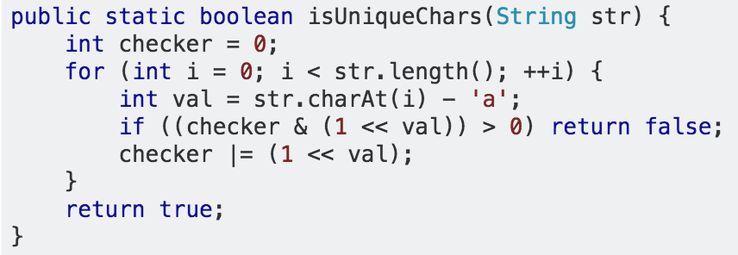

## **5. Big Data**

### **Top K Problem**

* Kth largest / smallest element in dataset
  + <http://www.geeksforgeeks.org/kth-smallestlargest-element-unsorted-array/>
  + <https://leetcode.com/problems/kth-smallest-element-in-a-bst/>
  + <http://www.geeksforgeeks.org/kth-smallestlargest-element-unsorted-array-set-2-expected-linear-time/>
* Find median in data stream <https://leetcode.com/problems/find-median-from-data-stream/>
* Top K frequent element <https://discuss.leetcode.com/topic/44237/java-o-n-solution-bucket-sort/6>

### **Cache Algorithm**

* Least Recently Used - Good when accessing recently used items more often

<http://www.geeksforgeeks.org/implement-lru-cache/>

Implement using double LL with Queue property, keep track of what’s in the LL using a HashSet so you only perform linear searches when you’re certain the object is in the LL

* Least Frequently Used - When recent accesses don’t influence future ones <http://stackoverflow.com/questions/21117636/how-to-implement-a-least-frequently-used-lfu-cache>

### **Bit Set** <http://www.dotnetperls.com/bitset-java>

### **External Sort** - external sort is for problems where you have to sort more data than you can store in memory at once.

<https://en.wikipedia.org/wiki/External_sorting#External_merge_sort>

<http://www.geeksforgeeks.org/b-tree-set-1-introduction-2/>

### **Bloom Filter** <http://billmill.org/bloomfilter-tutorial/>

### **MapReduce** <http://ksat.me/map-reduce-a-really-simple-introduction-kloudo/>

# **Data Structures** <http://www.geeksforgeeks.org/data-structures/> <http://quiz.geeksforgeeks.org/commonly-asked-data-structure-interview-questions-set-1/>

People build so many data structure only for one purpose - easy to manipulate. Those structure is supporting the computer science, just like how we place the goods in warehouse. Here is how we place the data.

### **Using Java.util on custom objects**

In order to use Java.util data structures like LL or HashTable you need to override the *equals* and *hashCode* methods. In order to use built in sorts the class needs to implement the *Comparable* interface and override the *compareTo* method. Here’s an example:

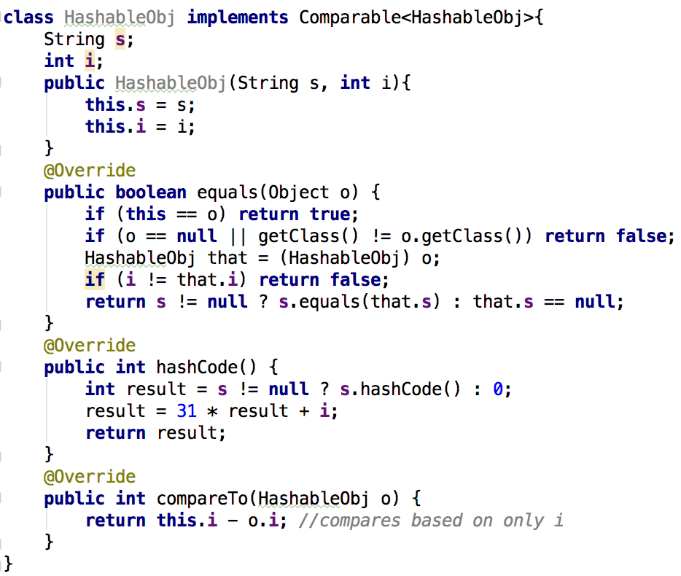

### **Array** <http://www.geeksforgeeks.org/category/c-arrays/>

-Watch out for IndexOutOfBound Errors and off by one

ArrayList are Java’s built in dynamic arrays, they copy into a 1.5 as big empty array when filled.

Vectors are synchronized ArrayLists. They double in size when filled.

### **Matrix (2-D Array)** <http://www.geeksforgeeks.org/category/matrix/>

Two dimension array.

Common interview questions: Print Spiral, Rotate, “MS Paint”, Count Islands, Queens Placement

-Key is to use clearly labeled variables to keep track of row/col and to watch out for IOB and off by one

### **String (Character Array)** <http://www.geeksforgeeks.org/category/c-strings/>

String is a special array with characters. Use StringBuilder class in Java to avoid repeated copies when concating/taking substrings because Java String class is immutable. String searching algorithms: <https://www.topcoder.com/community/data-science/data-science-tutorials/introduction-to-string-searching-algorithms/>

Lib functions:

* str.length(); str.charAt(n); str.equals(str2); str.substring(start,stop);
* Character.toString(c); str.toCharArray();
* StringBuilder(str); sb.append(str); sb.charAt(n); sb.deleteCharAt(n); sb.delete(start,end); sb.setCharAt(index,c); sb.length(); sb.toString(); sb.reverse(); sb.insert(offset, str);

Ascii: has 128 characters, you can get ascii values of a char by casting it to (int)

Unicode: has thousands of characters, encoded into UTF-32 or UTF-8

**LinkedList** - can be double/single linked, cyclic lists, List class may contain pointers to head + tail/number of elements etc.

<http://www.geeksforgeeks.org/data-structures/linked-list/>

-There is a LinkedList class in Java.utils

-ArrayList vs LinkedList: ArrayList has better spatial locality, LL is easier to append stuff into the middle

-LL problems often use the “runner” technique where one pointer moves at a faster rate than another

-LL problems often use recursion

-Understand how to implement Node/LL from scratch

Common Interview Questions: add/multiply 2 numbers whose digits are represented as LL’s; find intersection of 2 LL’s; given circular LL return node at start of loop; reverse [k-j] sublist or every kth-jth sublist (EPI 8.4) ; sort a LL

-write helper functions to swap nodes

-to deal with not being able to move backwards you’ll often reverse a segment of the list: ie to check if LL is palindrome you’ll reverse the 2nd half then traverse start->middle and middle->end comparing each value

<http://www.geeksforgeeks.org/merge-sort-for-linked-list/>

### **Stack** - L.I.F.O, usually implemented with LL or dynamic array (array is better, but harder to implement b/c you need to write code for a circular array), good for recursive problems.. Can also be used to implement DFS

### <http://www.geeksforgeeks.org/category/stack/>

Stack<O> s = new Stack<O>(); s.push(o); s.pop(); s.peek(); s.isEmpty();

Common Interview Questions: implement 2 stacks using 1 array; implement a max/min stack that keeps track of current max/min; implement Queue using 2 stacks; implement priority stack using 2 stacks

-Understand how to use a stack to mimic recursion (especially for tree problems)

### **Queue** - F.I.F.O, usually implemented with LL or dynamic array (array is better but LL is built into Java), used in BFS and caching problems

### <http://www.geeksforgeeks.org/category/queue/>

### <http://www.geeksforgeeks.org/applications-of-heap-data-structure/>

Queue<O> q = new LinkedList<O>(); q.add(o); q.remove(); q.peek(); q.isEmpty();

-You can implement a special stack/queue using a double linked list that keeps track of head + tail.. It will have the properties of a stack AND a queue

### **Binary Heap** - complete binary tree that satisfies the heap property: in a min Heap each child>parent; in a max heap each child<parent... used for implementing priority queues, HeapSorting and Dijsktra’s algorithm.

### <https://www.cs.cmu.edu/~adamchik/15-121/lectures/Binary%20Heaps/heaps.html>

### <http://www.geeksforgeeks.org/category/heap/>

### <http://www.geeksforgeeks.org/why-is-binary-heap-preferred-over-bst-for-priority-queue/>

-Binary Heaps can be implemented using Arrays with elements following an in-order traversal

-Should know how to implement Node and Array versions of a min/max heap, inserts/deletes use bubbling to restore the heap property

-”Almost sorted array” question is solved maintaining a size k+1 heap as you traverse the array and popping off/adding element at each index

-Binomial Heaps make it easier to merge 2 heaps together

-Know how to implement a Priority Queue: this is just a max heap with objects that have comparable priority levels

-Priority Queues are used in graph searching algorithms and task scheduling

### **Fibonacci Heap** - Faster than Binary/Binomial Heaps

### <https://www.cs.princeton.edu/~wayne/teaching/fibonacci-heap.pdf>

-Performs FindMin, Insert, DecreaseKey, Merge in O(1) and DeleteMin in O(Log n)

-Unlike binomial heaps, FH doesn’t consolidate trees after each insert().. Instead it waits till next delete-min to do it.. It can do this by keeping a list of subtrees

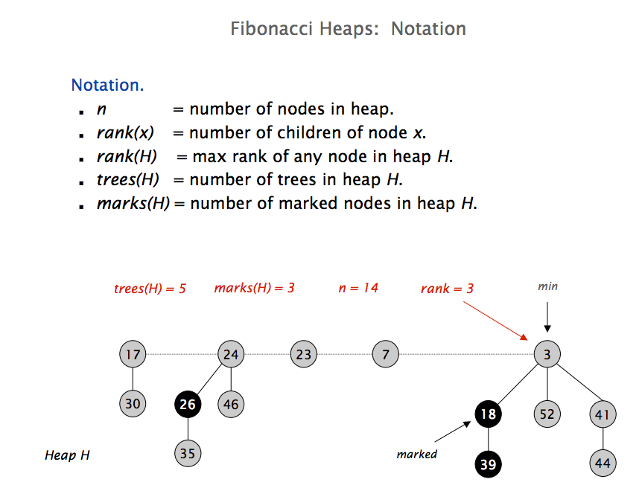

Insert: create new singleton tree, add to root list, update min pointer if necessary

Merge: make larger root be child of smaller root

Delete Min: delete min, meld its children into root list, update min, *consolidate trees so no 2 roots have the same rank* (go through set of trees and merge ones with same rank)

Decrease Key: if heap order isn’t violated, just decrease the key value. If heap order violated cut the tree rooted at the key and move it to list.

### **Binary Tree** - good for searching, implementing heaps. Traveling/searching usually uses recursive calls.

### -Traversals:

### -In-order (LPR): used to access elements in BST from lowest to highest, a modified In-Order traversal can be used to access elements from highest to lowest (you would use a stack or an arrayList); used to check if tree is a BST

### -Pre-Order (PLR): used to make copies of the tree or to get a prefix expression in a Trie.

### -Post-order (LRP): used to delete the tree (malloc each node) or to get the postfix expression in a Trie

- Level-Order Traversal: use a Queue of LL’s for each level.. Print cur & put children in Queue, then pop from Queue into cur and repeat.. O(n) time

- Need to understand the order/implementation and uses of each of these cold

- Can build a BST using Pre/Post/Level traversal but not In-Order. A (hard) interview question is build all possible trees from an in-order traversal

-Rooted trees: nodes keep a reference to the root

-In array representation, children of i’th element are 2i + 1 and 2i + 2

### <http://www.geeksforgeeks.org/category/tree/>

### Uses: <http://puu.sh/pT6hX/65a837d6b9.png>

### **Binary Search Tree**

Not part of Java.utils so you have to implement it yourself.. Including the AVL/RB part

Insertion: starts at root and compares to each element then takes path L or R until it attaches itself as a leaf

Delete: if leaf, pop it off. If has 1 child simply replace it with its child. If has 2 children find next biggest element using in-order traversal: if it’s a leaf simply swap the 2, if it has children swap the 2 and append the right children of delete node to end of swapped child chain

<http://quiz.geeksforgeeks.org/binary-search-tree-set-1-search-and-insertion/>

<http://www.geeksforgeeks.org/category/binary-search-tree/>

Vs HashTable <http://www.geeksforgeeks.org/advantages-of-bst-over-hash-table/>

### **Red/Black Tree + AVL Tree** - self balancing, ensures nlogn. AVL maintains a more rigid balance (slightly faster lookups), but at the cost of slightly slower insertions. Use AVL if doing more lookups than insertions, RB tree if the opposite.

<http://www.geeksforgeeks.org/red-black-tree-set-1-introduction-2/>

-try recoloring first

-rotate if can’t recolor

<http://www.geeksforgeeks.org/avl-tree-set-1-insertion/>

<http://www.sanfoundry.com/java-program-implement-avl-tree/>

-AVL nodes have Data, LeftChild, RightChild and Height (leftChild.height-rightChild.height) properties

-AVL structure has a reference to it’s root

Insertion:

-Insert like normal BST but update heights as you go, then move up to parent & grandparent and check height balance. First direction in the 4 way conditional will come from the grandparent, 2nd from the parent. Basic idea is to turn LR cases into LL cases and to turn RL cases into RR cases then fix them with a left or right rotate

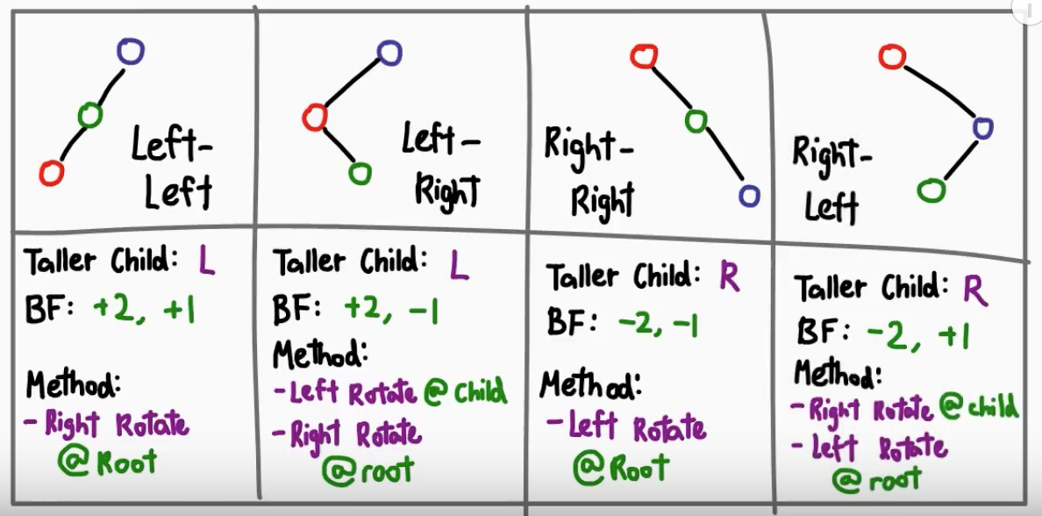

-Key is to remember it recurses, so after it inserts node as a leaf it’ll execute AVL part of the code in reverse order from new node to root of tree

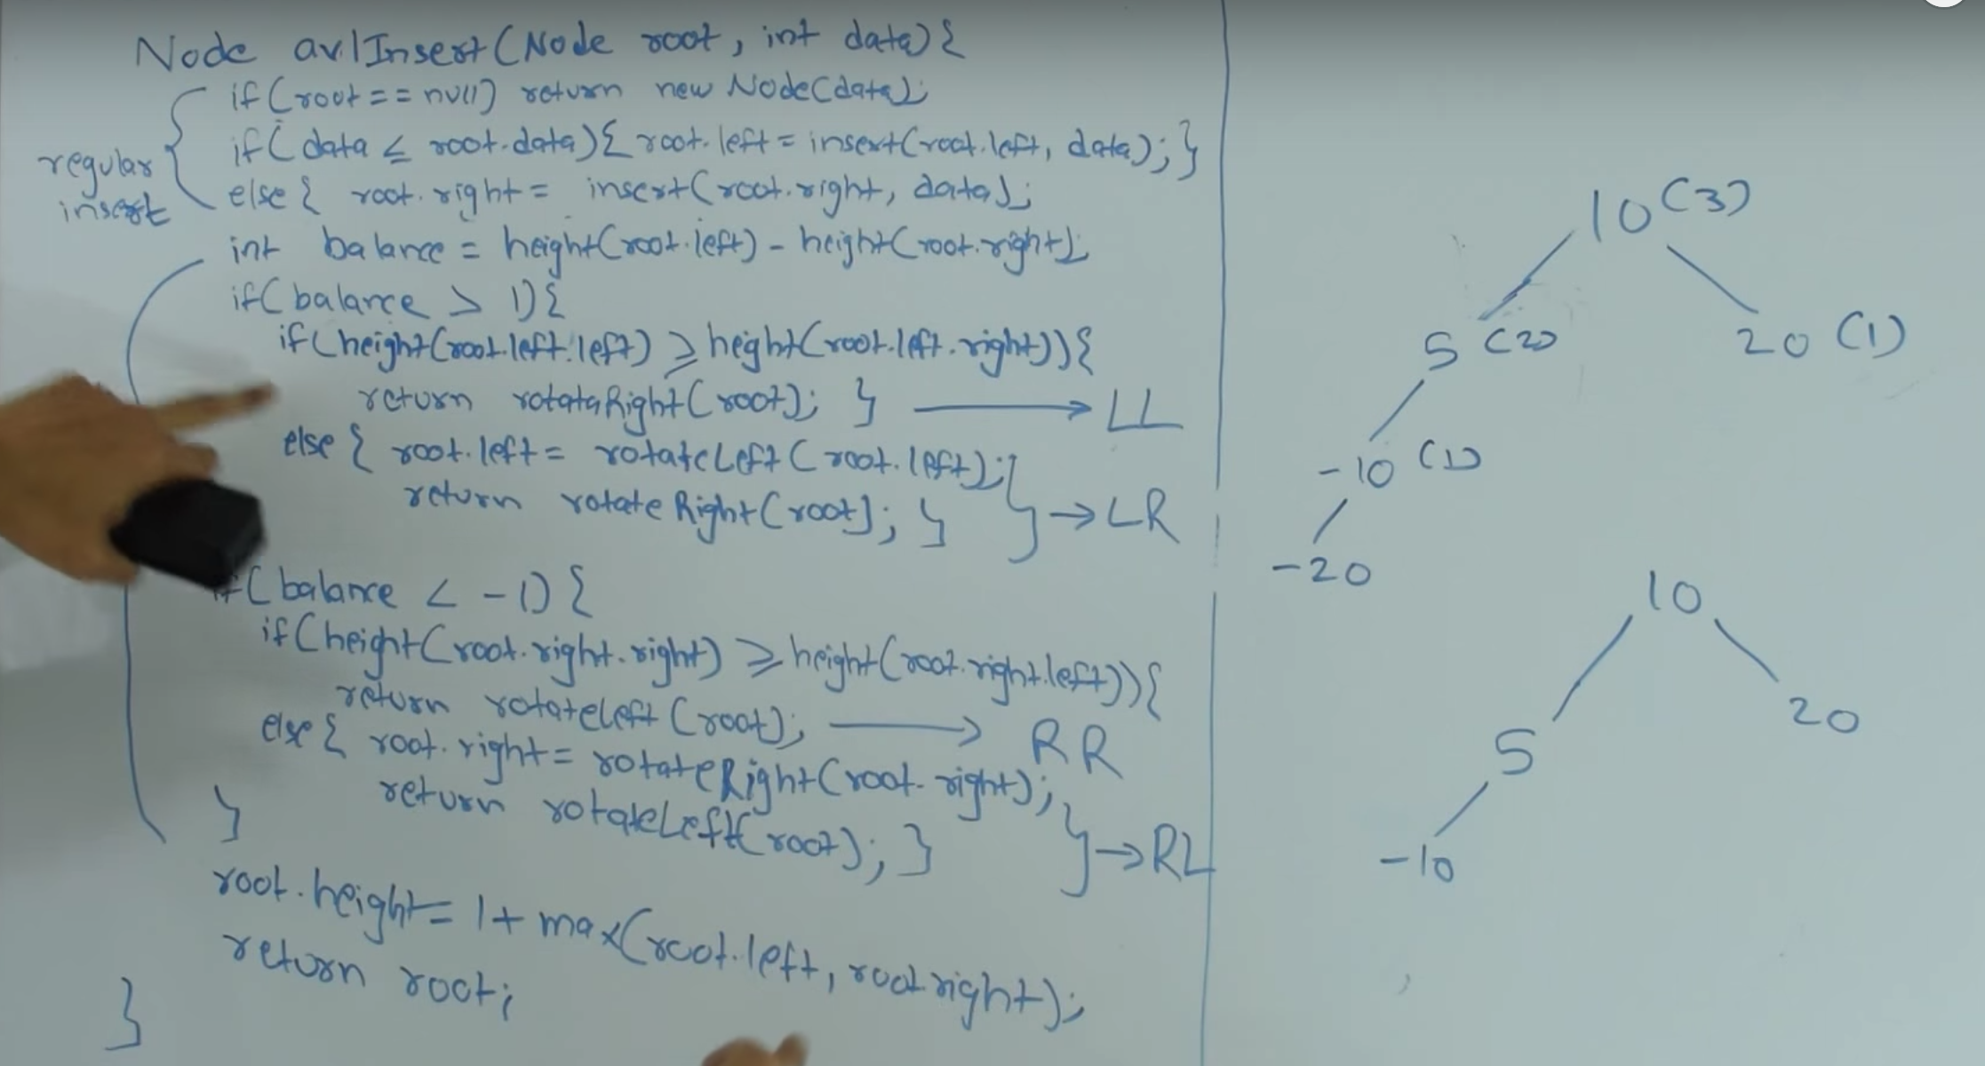

### **Prefix Tree aka Trie** - good for linear retrieval of combinations/suffixes

<http://www.geeksforgeeks.org/trie-insert-and-search/>

-Variant of n-ary tree with characters stored in each node so each node could have ALPHABET_SIZE+1 children where the char * is used to denote end of a word

-Each path down represents a word.. Often used to hold entire english dictionary and quickly look up prefixes

### **Hash Table/Map/Set** - quick inserts and removes, but use up lots of memory

-Hashing: <http://www.geeksforgeeks.org/hashing/>

-Sum the ascii values of a string representation and & or * it with a large prime (ie 0x7fffffff)

-add any ints/other data fields that make the object unique, then mod with size of HT

-Collision mitigation techniques

- linear, quadratic vs double hashing vs direct addressing vs chaining

- linear: utilizes locality of reference, but faces clustering issues.

-if using linear/quadratic probing keep the hashtable < half full, when it reaches half fullness re-allocate to a 2x size similar to how an ArrayList is implemented

-linear probing comes with primary clustering issues which are addressed thru quadratic probing but that in turn comes with secondary clustering issues.

-HashMap vs HashTable: HashTable is synchronized, bit slower and doesn’t allow null values.

<http://javahungry.blogspot.com/2014/03/hashmap-vs-hashtable-difference-with-example-java-interview-questions.html>

-HashSet: doesn’t allow duplicates, put() and contains()

<http://beginnersbook.com/2013/12/hashset-class-in-java-with-example/>

-LinkedHashMap: <http://www.tutorialspoint.com/java/java_linkedhashmap_class.htm>

<https://www.cs.auckland.ac.nz/software/AlgAnim/hash_tables.html>

<http://www.geeksforgeeks.org/implementing-our-own-hash-table-with-separate-chaining-in-java/>

-Iterating a HashTable/Map: Set s = ht.keySet(); for(String key: s){..

-Understand how to implement chaining for duplicate entries, you make the value an ArrayList

### **BitSet** - can be used to store boolean flags for integers, might come up in a problem where you have little memory and a large array you need to check for duplicates.. Think a more space efficient boolean array

### **Disjoint Set** - linked list vs forrest representations

### <http://www.geeksforgeeks.org/disjoint-set-data-structures-java-implementation/>

-Can use parent[] and rank[] arrays to represent tree, “representatives” ie roots of tree will be their own parents.. Simple way to order representatives is to make them the largest element in the tree

### **Graph**

### <http://www.geeksforgeeks.org/category/graph/> ; <http://www.sanfoundry.com/java-programming-examples-graph-problems-algorithms/>

-Representations: Matrix vs LinkedList

-LL: each Node stores data + Array of connected Nodes, in a double linked graph you would keep track of inward edges and outward edges

-M: Edges stored in NxN boolean Matrix where M[i][j] = true iff. Edge from i->j, data stored in A[N]. Slower b/c you have to iterate through all nodes.

<http://www.geeksforgeeks.org/graph-and-its-representations/>

-DFS: uses recursion. Can be used to detect cycle.Can be used to implement topological sort. Solve puzzles with only 1 solution like mazes. Key concepts of discovery time and finishing time for vertices

-BFS: Uses a queue. Can be used for shortest path between 2 nodes in weighted edge graph. More efficient than BFS.

-Shortest path from source to every V (Weighted edges):

Dijkstra’s - O(E LogV):

-Initialize minHeap(V) of distance:vertex values, root=0 everything else =INF

-while minHeap!=empty: pop minimum distance vertex and update V’s connected to it if the path through current vertex is shorter than their current distance

<http://www.geeksforgeeks.org/greedy-algorithms-set-7-dijkstras-algorithm-for-adjacency-list-representation/>

<http://www.codeproject.com/Articles/9880/Very-simple-A-algorithm-implementation>

-Shortest path with Negative edges/detect negative weight cycles:

Bellman-Ford - O(V E):

-Uses a Map<Vertex, <Distance,Parent>> where distance is the distance from source and parent is the previous vertex in the path source->Vertex

-Call the relax(edge uv) function on each edge V-1 times

-to detect negative edge weight cycle call relax on each edge again and if the condition distance[v] > distance[u] + weightEdge(u,v) is met for any edge there exists a negative weight cycle

<http://www.geeksforgeeks.org/dynamic-programming-set-23-bellman-ford-algorithm/>

-All pairs shortest path, weighted edges (works with negative weight edges). Used for Longest Path

Floyd-Warshall - O(V^3)

-Add all edges to a VxV size matrix, set all other values to INF then:

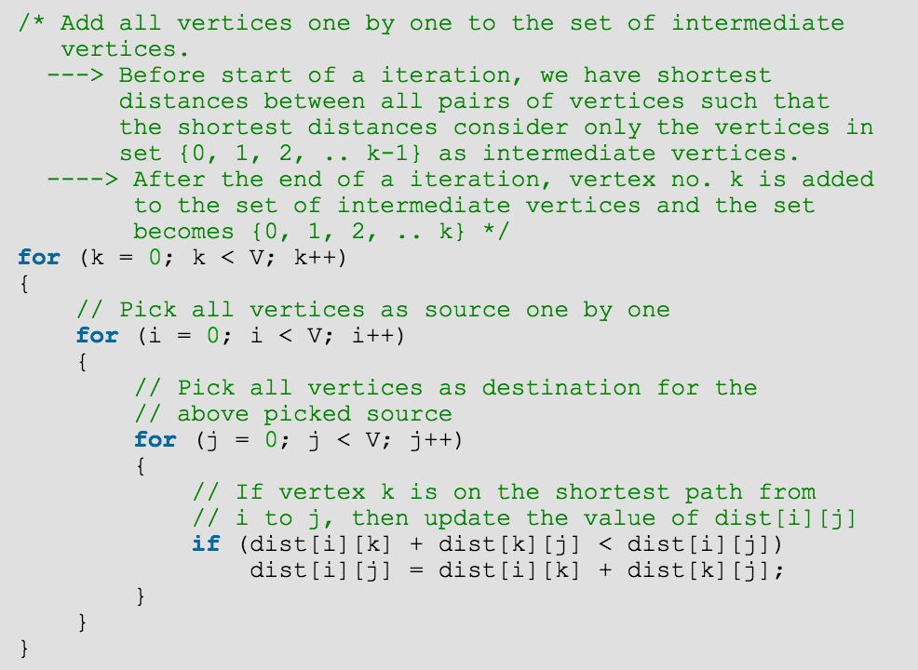

<http://www.geeksforgeeks.org/dynamic-programming-set-16-floyd-warshall-algorithm/>

Easier to remember:

for(intermediate = 0; intermediate < Vertices; intermediate++)

for(source=0; source < Vertices; source++)

for(destination = 0; destination < Vertices; destination++)

if(dist[source][intermediate] + dist[intermediate][destination] < dist[source][destination]):

dist[source][destination] = dist[source][intermediate] + dist[intermediate][destination];

-Minimum spanning trees - used to for network design, to approximate traveling salesman problem

<http://www.geeksforgeeks.org/greedy-algorithms-set-2-kruskals-minimum-spanning-tree-mst/>

The difference: <http://puu.sh/pT5TD/dd69f679a5.png>

-Topological Sort - used for scheduling tasks with dependencies

<http://www.geeksforgeeks.org/topological-sorting/>

-Detect cycles with negative weights: Bellman-Ford algorithm or modified DFS

-DAG - Direct Acyclic Graph: finite directed graph with no directed cycles

Common Problems:

-Graph coloring <http://www.geeksforgeeks.org/graph-coloring-applications/>

-Detect cycles in directed graph: <https://www.youtube.com/watch?v=rKQaZuoUR4M&index=13>

Graph<V> G = new Graph<V>; G.add(vertex); G.connect(v_from, v_to); G.remove(vertex); G.getInWardEdges(vertex); G.getOutWardEdges(vertex); G.size(); G.contains(vertex);

# **P/NP Problems**

<http://www.geeksforgeeks.org/np-completeness-set-1/>

<https://www.quora.com/What-are-some-examples-of-problems-which-are-1-NP-but-not-NP-Complete-2-NP-Complete-3-NP-Hard-but-not-NP-Complete>

# **Computer Architecture/OS**

-memory: stack vs heap

-locks and mutexes and semaphores and monitors

-deadlock and livelock and how to avoid them

-processes, threads and concurrency issues

-what resources a processes needs, and a thread needs, what’s shared between processes vs threads

-how context switching works, and how it's initiated by the operating system and underlying hardware

-scheduling

-concurrent programming in java

-how many bits in a byte etc

-utf8 format <http://stackoverflow.com/questions/28890907/implement-a-function-to-check-if-a-string-byte-array-follows-utf-8-format>

# **Object Oriented Programming**

### **Java Iterators**

### <http://www.tutorialspoint.com/java/java_using_iterator.htm>

Create using Iterator i = collection.iterator(); then while(i.hasNext()){ ..

-Used for ArrayList, LL, Vector, Stack, HashTable, HashSet, HashMap

## **Java Iterators**

-Allow you to define methods and classes that can handle arguments of different (but similar) types.

-The generic type is declared within angle brackets ie <E> and precedes a method’s return type

## **Java Multithreading**

-Extend Thread class and override run() and start() methods

## **Design Patterns**

<http://www.tutorialspoint.com/design_pattern/design_pattern_interview_questions.htm>

<http://www.mcdonaldland.info/files/designpatterns/designpatternscard.pdf>

<http://www.informit.com/guides/content.aspx?g=java&seqNum=607>

**Singleton** - class can only have one instance

Factory - interface for creating instances of a class. It’s subclass decides which class to instantiate.

**Listener/Observer** - listener has an update method that is called every time something is updated. When update is called each observer gets updated. Used for GUI’s, apps etc

**Model-View-Controller (MVC)** - used for user interfaces to keep data separate from UI similar to Listener/Observer. MVC enforces the good practice of keeping data generation seperate from display.

## **Principles**

### **Open - Close**

##### **Open for extension but closed for modifications**

The design and writing of the code should be done in a way that new functionality should be added with minimum changes in the existing code. The design should be done in a way to allow the adding of new functionality as new classes, keeping as much as possible existing code unchanged.

##### **Example**

class ShapeEditor{  
 void drawShape(Shape s){  
 if (s.m_type==1)  
 drawRectangle(s);  
 else if (s.m_type==2)  
 drawCircle(s);  
 };  
 void drawRectangle(Shape s);  
 void drawCircle(Shape s);  
}  
class Shape{}  
class Rectangle extends Shape{}  
class Circle extends Shape{}  
  
//---> Every time if new shape added, we have to modify method in the editor class, which violates this rule!  
// ---> change!!! write draw method in each shape concreted class  
class Shape{ abstract void draw(); }  
class Rectangle extends Shape{ public void draw() { /*draw the rectangle*/} }  
class Circle extends Shape{ public void draw() { /*draw the circle*/} }  
class ShapeEditor{  
 void drawShape(Shape s){ s.draw(); }  
 }

### **Dependency Inversion**

The low level classes the classes which implement basic and primary operations(disk access, network protocols,...) and high level classes the classes which encapsulate complex logic(business flows, ...). The last ones rely on the low level classes.

High-level modules should not depend on low-level modules. Both should depend on abstractions.

Abstractions should not depend on details. Details should depend on abstractions.

When this principle is applied it means the high level classes are not working directly with low level classes, they are using interfaces as an abstract layer.

##### **Example**

class WorkerWithTechOne{}  
class Manager{  
 WorkerWithTechOne worker;  
}  
// --> what if add other workers with other techniques?  
// --> abstract worker!  
interface Worker{}  
class WorkerWithTechOne implements Worker{}  
class WorkerWithTechTwo implements Worker{}  
class Manager{  
 Worker worker;  
}

### **Interface Segregation**

##### **Clients should not be forced to depend upon interfaces that they don't use.**

Instead of one fat interface, many small interfaces are preferred based on groups of methods, each one serving one submodule.

##### **Example**

interface work{  
 public void work();  
 // too much methods!  
 public void life();  
 public void rest();  
}  
// ---> change!!!  
interface work{public void work();}  
interface life{public void life();}  
interface rest{public void rest();}

### **Single Responsibility**

A class should have only one reason to change.

A simple and intuitive principle, but in practice it is sometimes hard to get it right.

This principle states that if we have 2 reasons to change for a class, we have to split the functionality in two classes. Each class will handle only one responsibility and on future if we need to make one change we are going to make it in the class which handle it. When we need to make a change in a class having more responsibilities the change might affect the other functionality of the classes.

##### **Example**

interface Iemail{  
 public void setSender(String sender);  
 public void setReceiver(String receiver);  
 public void setContent(String content);  
 // --> change!!!  
 public void setContent(Content content);  
}  
// --> Content can be change to HTML or JSON or other kinds of format  
// so it should be splited   
interface Content {  
 public String getAsString(); // used for serialization  
}  
class email implement Iemail{  
 public void setSender(String sender) { set sender; }  
 public void setReceiver(String receiver) { set receiver; }  
 public void setContent(String content) {set content; }  
 // --> change!!!  
 public void setContent(Content content) { set content; }  
}

### **Liskov's Substitution**

Derived types must be completely substitutable for their base types.

This principle is just an extension of the Open Close Principle and it means that we must make sure that new derived classes are extending the base classes without changing their behavior.

This principle considers what kind of derived class should extends a base class.

##### **Example**

// Violation of Likov's Substitution Principle  
class Rectangle {  
 protected int m_width;  
 protected int m_height;  
  
 public void setWidth(int width){ m_width = width; }  
 public void setHeight(int height){ m_height = height; }  
}  
  
class Square extends Rectangle {  
 public void setWidth(int width){  
 m_width = width; m_height = width;  
 }  
 public void setHeight(int height){  
 m_width = height; m_height = height;  
 }  
}

## **Muddiest Points**

### **Composite v.s Aggregation**

##### **Simple rules:**

A "owns" B = Composition : B has no meaning or purpose in the system without A

A "uses" B = Aggregation : B exists independently (conceptually) from A

##### **Example 1:**

A Company is an aggregation of People. A Company is a composition of Accounts. When a Company ceases to do business its Accounts cease to exist but its People continue to exist.

##### **Example 2: (very simplified)**

A Text Editor owns a Buffer (composition). A Text Editor uses a File (aggregation). When the Text Editor is closed, the Buffer is destroyed but the File itself is not destroyed.

### **Interface v.s Abstract Class**

#### **Interface**

##### **Characters**

* Allow multiple inheritance.
* No concrete method.
* No constructor.
* No instance variable, it only allow static final constant with the assignment.
* Can extend interface.
* Cannot be initialized. But sometime the interface can initialized by providing anonymous inner class.

##### **Guide**

* When you think that the API will not change for a while.
* When you want to have something similar to multiple inheritance.
* Enforce developer to implement the methods defined in interface.
* Interface are used to represent adjective or behavior

#### **Abstract Class**

##### **Characters**

* Can extend abstract class.
* Allow concrete method, provide some default behavior.
* Allow abstract method.
* Cannot be initialized.

##### **Guide**

* On time critical application prefer abstract class is slightly faster than interface.
* If there is a genuine common behavior across the inheritance hierarchy which can be coded better at one place than abstract class is preferred choice.

#### **All in all**

Interface and abstract class can work together also where defining function in interface and default functionality on abstract class. It also called Skeletal Implementations.

## **Reference**

1. OO Design Website: [oodesign.com](http://www.oodesign.com/)
2. OOD Question on Stackexchange: [Composite v.s Aggregation](http://programmers.stackexchange.com/questions/61376/aggregation-vs-composition)

# **System Design**

<http://www.aosabook.org/en/distsys.html>

Steps (S - N - A - K - E)

* Scenario: (Case/Interface)
* Necessary: (Contain/Hypothesis/Design goals)
* Application: (Services/Algorithms)
* Kilobyte: (Data)
* Evolution

**Scenario**

Enumerate All possible cases & requirements

* Register / Login
* Main Function One
* Main Function Two
* ...

Sort Requirement

-Think about sub-requirements and priorities

**Necessary**

* Ask:
  + User Number
  + Active Users
* Predict
  + User
    - Concurrent User:
      * 
    - Peak User:
      *  : c is a constant
    - Future Expand:
      * Users growing: max user amount in 3 months
  + Traffic
    - Traffic per user (bps)
    - MAX peak traffic
  + Memory (< 1 TB is acceptable)
    - Memory per user
    - MAX daily memory
  + Storage
    - Type of files (e.g movie, music need to store multiple qualities)
    - Amount of files

**Application**

* Replay the case, add a service for each request
* Merge the services

**Kilobyte**

* Append dataset for each request below a service
* Choose storage types

**Evolution**

* Analyze
  + with
    - Better: constrains
    - Broader: new cases
    - Deeper: details
  + from the views of
    - Performance
    - Scalability
    - Robustness

**Principles of Web Distributed System Design:**

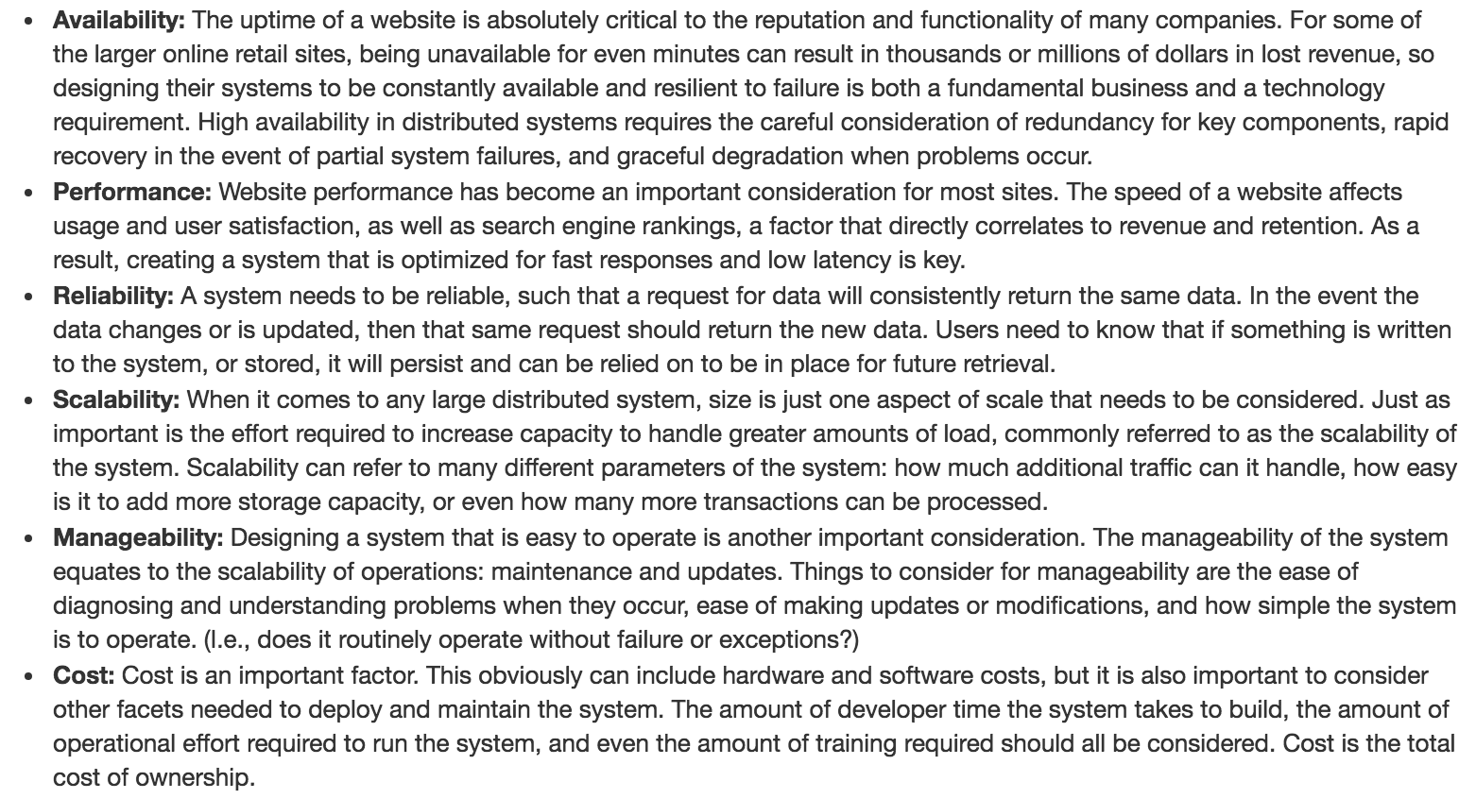

**Useful Topics:**

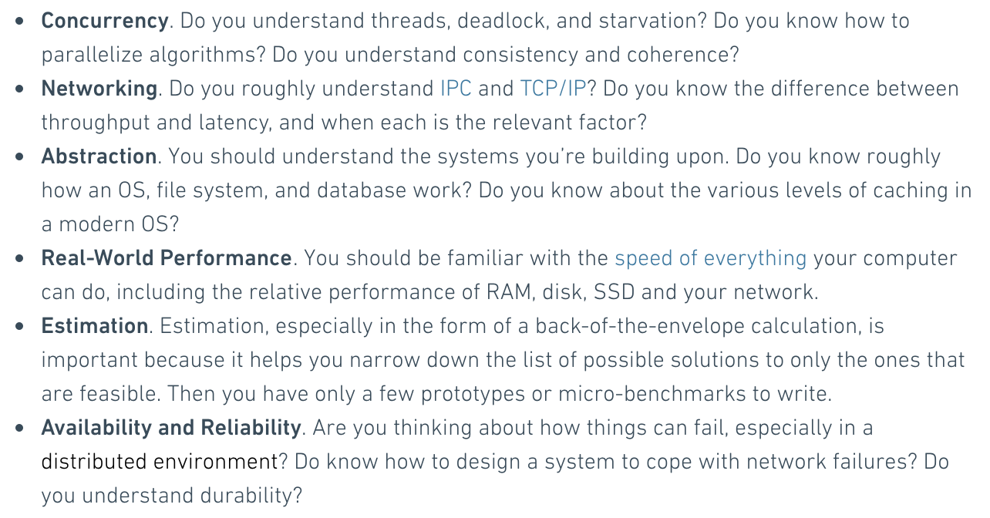

**Fallacies of distributed computing (Address these in an interview and how to handle):**

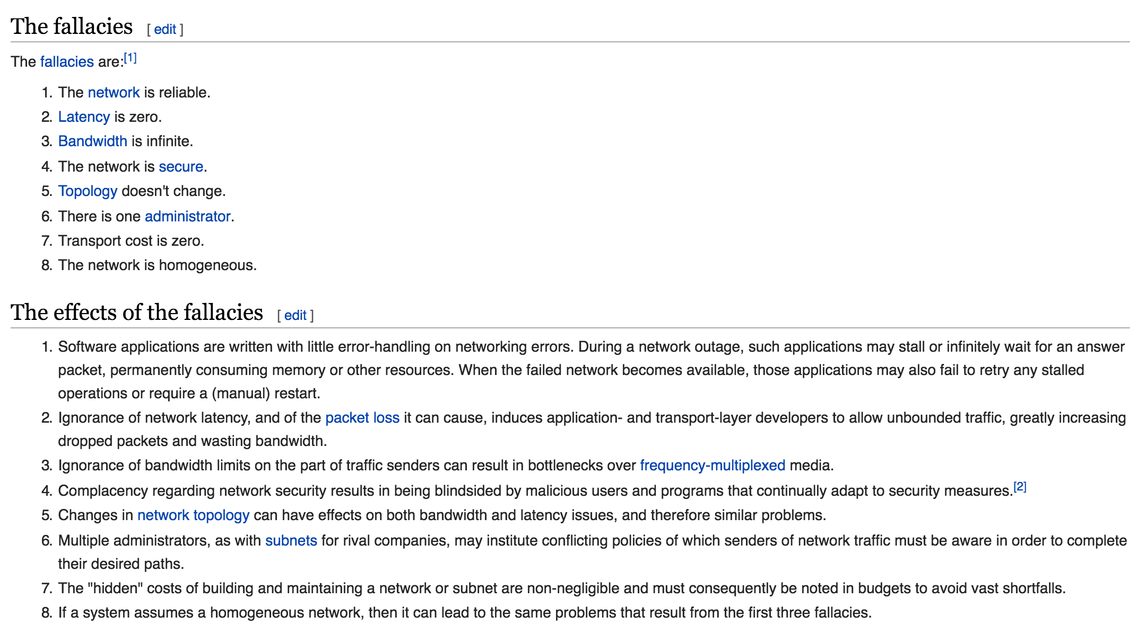

System design is a wide topic. Even a experienced software engineer at top IT company may not be an expert on system design. Many books, articles, and solve real large scale system design problems may needed.

-powers of 2 table for scalability/memory problems: <http://puu.sh/pLwAj/2224cfba17.png>

<https://github.com/checkcheckzz/system-design-interview>

<http://www.lecloud.net/tagged/scalability>

<http://horicky.blogspot.com/2010/10/scalable-system-design-patterns.html>

Random notes:

-IPC (Inter-Process Communication) is how processes communicate on local machines (shared memory) it’s much faster that TCP/IP communications between networked machines.

-RAM is faster than disk, it’s used to temporarily store data you’re using but you lose it in event of power failure.. Reading to disk is slower but it can store more data and persistently store it. SSD’s are like the hybrids of RAMs and disks.

- Focus on availability, performance, reliability, scalability, manageability, cost

- *services*, *redundancy*,*partitions*, and *handling failure*

-Shard your DB’s to store more in memory, either built in or implement hash and mod strategy.. Horizontal vs Vertical sharding

Sharding refers to an architecture where data is distributed across commodity (cheap) computers: a distributed, shared-nothing architecture in which all nodes work to satisfy a given query, but they work independently of each other, reporting back to an initiator or master node when done. The nodes do not share memory or disk space. Being cheap, we can afford many nodes, which makes the platform massively parallel processing (MPP). Data is typically distributed across nodes via a distribution key (or segmentation clause, in Vertica). So orders would be contained in a single table, perhaps called orders_fact, and it would be distributed across all nodes, with the data being assigned to a node via the distribution key. Partitioning: there are three kinds - horizontal, vertical, and table partitioning.

Horizontal Partitioning organizes data, say addresses, by a key which in this case might be postal code/geographical region, so that eastern postal codes are in the eastpostalcode table and western postal codes are in the westpostalcode table. These two tables are identical but with different data.

Vertical partitioning involves splitting a table between two columns, so all columns to the left of the split are in one table, and those to the right in another. This practice is unusual. The use case is when some of the columns are hardly ever used or are huge.

Table partitioning is also horizontal, but it is logical, not physical, and is contained within a single table. Data is organized by a partition key, which is a lot like a distribution key for nodes. This allows queries to run faster by skipping irrelevant partitions.

-Memcache or self implemented LRU cache for faster reads (be careful of cache misses)

-Implement a RESTful API to begin with, know about GET, PUT, PATCH, POST, DELETE and response codes

- Load balancer to process multiple webserver requests, remember each server should host the same data.. So they shouldn’t be used to store user data (have a separate server for that)

-watch out for uptime and “single point of failure” concerns

-Do preprocessing so the heavy computation isn’t done when the user requests it and there are no delays.. Pre-compute general data + common queries

-Async queueing.. If multiple users are making heavy requests put them in a queue and asynchronously work on them.. Any time you do something time consuming do it asynchronously

-CAP theorem proves that you cannot get Consistency, Availability and Partitioning at the the same time.. NoSQL db’s relax on the consistency requirement

-Master/Slave model for DB’s.. when the master is updated it’s slaves are asynchronously updated.. Helps avoid data loss if something crashes

-Trade-offs: Performance vs Scalability, Latency vs Throughput, Availability vs Consistency

-Latency is the time required to perform some action or to produce some result. Latency is measured in units of time -- hours, minutes, seconds, nanoseconds or clock periods.

-Throughput is the number of such actions executed or results produced per unit of time. This is measured in units of whatever is being produced (cars, motorcycles, I/O samples, memory words, iterations) per unit of time. The term "memory bandwidth" is sometimes used to specify the throughput of memory systems.

-Redundant array of independent disks (RAID) is a technique for storing the same data on multiple hard disks to increase read performance and fault tolerance. In a properly configured RAID storage system, the loss of any single disk will not interfere with users' ability to access the data stored on the failed disk. RAID has become a standard but transparent feature in both enterprise-class and consumer-class storage products. RAID storage systems aren't new or sexy, so they've fallen out of the limelight as a feature that vendors promote. "When you go to a car dealership, how often do they tell you about the tires on the car?" asked Greg Schulz, founder and senior analyst with StorageIO Group, a Stillwater, Minn.,-based technology analyst and consulting firm. "RAID's taken for granted. It's a feature. It's a standard function."

-Cache objects

Some ideas of objects to cache:

* user sessions (never use the database!)
* fully rendered blog articles
* activity streams
* user<->friend relationships

<https://en.wikipedia.org/wiki/Apache_Cassandra> - distributed hash table

AWS elastic

Redis is an external persistent cache, can be used to store user sessions (“outsourcing” sessions).. Redis has external DB like features like persistent storage and built in data structures.. Redis could replace a DB if used properly.. But if you just want a scalable cache you can use memcache

Capistrano or Ruby on Rails can be used to deploy code base to all your servers so there isn’t one server that is serving old data

Denormalize your DB from the start (no joins in DB queries).. Use a NoSQL db like Mongo

Use Memcache or Redis as a buffer between application and storage layers

<https://en.wikipedia.org/wiki/Apache_Hadoop> uses MapReduce. Is a parallel processing framework.. MapReduce is often used to deal with I/O bottlenecks

**Apache Kafka** is an open-source message broker project developed by the Apache Software Foundation written in Scala. The project aims to provide a unified, high-throughput, low-latency platform for handling real-time data feeds. It is, in its essence, a "massively scalable pub/sub message queue architected as a distributed transaction log,"[2] making it highly valuable for enterprise infrastructures to process streaming data.

**Apache Spark** provides programmers with an application programming interface centered on a data structure called the resilient distributed dataset (RDD), a read-only multiset of data items distributed over a cluster of machines, that is maintained in a fault-tolerant way.[2] It was developed in response to limitations in the MapReduce cluster computing paradigm, which forces a particular linear dataflow structure on distributed programs: MapReduce programs read input data from disk, map a function across the data, reduce the results of the map, and store reduction results on disk. Spark's RDDs function as a working set for distributed programs that offers a (deliberately) restricted form of distributed shared memory.[3]

**Bigtable** maps two arbitrary string values (row key and column key) and timestamp (hence three-dimensional mapping) into an associated arbitrary byte array. It is not a relational database and can be better defined as a sparse, distributed multi-dimensional sorted map.[11]:1 Bigtable is designed to scale into the petabyte range across "hundreds or thousands of machines, and to make it easy to add more machines [to] the system and automatically start taking advantage of those resources without any reconfiguration".[12] Each table has multiple dimensions (one of which is a field for time, allowing for versioning and garbage collection). Tables are optimized for Google File System (GFS) by being split into multiple tablets – segments of the table are split along a row chosen such that the tablet will be ~200 megabytes in size. When sizes threaten to grow beyond a specified limit, the tablets are compressed using the algorithm BMDiff[13][14] and the Zippy compression algorithm[15] publicly known and open-sourced as Snappy,[16] which is a less space-optimal variation of LZ77 but more efficient in terms of computing time. The locations in the GFS of tablets are recorded as database entries in multiple special tablets, which are called "META1" tablets. META1 tablets are found by querying the single "META0" tablet, which typically resides on a server of its own since it is often queried by clients as to the location of the "META1" tablet which itself has the answer to the question of where the actual data is located. Like GFS's master server, the META0 server is not generally a bottleneck since the processor time and bandwidth necessary to discover and transmit META1 locations is minimal and clients aggressively cache locations to minimize queries.

**MapReduce** is a framework for processing parallelizable problems across large datasets using a large number of computers (nodes), collectively referred to as a cluster (if all nodes are on the same local network and use similar hardware) or a grid (if the nodes are shared across geographically and administratively distributed systems, and use more heterogenous hardware). Processing can occur on data stored either in a filesystem (unstructured) or in a database (structured). MapReduce can take advantage of the locality of data, processing it near the place it is stored in order to reduce the distance over which it must be transmitted.

"Map" step: Each worker node applies the "map()" function to the local data, and writes the output to a temporary storage. A master node ensures that only one copy of redundant input data is processed.

"Shuffle" step: Worker nodes redistribute data based on the output keys (produced by the "map()" function), such that all data belonging to one key is located on the same worker node.

"Reduce" step: Worker nodes now process each group of output data, per key, in parallel.

MapReduce allows for distributed processing of the map and reduction operations. Provided that each mapping operation is independent of the others, all maps can be performed in parallel – though in practice this is limited by the number of independent data sources and/or the number of CPUs near each source. Similarly, a set of 'reducers' can perform the reduction phase, provided that all outputs of the map operation that share the same key are presented to the same reducer at the same time, or that the reduction function is associative. While this process can often appear inefficient compared to algorithms that are more sequential (because multiple rather than one instance of the reduction process must be run), MapReduce can be applied to significantly larger datasets than "commodity" servers can handle – a large server farm can use MapReduce to sort a petabyte of data in only a few hours.[12] The parallelism also offers some possibility of recovering from partial failure of servers or storage during the operation: if one mapper or reducer fails, the work can be rescheduled – assuming the input data is still available.

Design a CDN network (Content Delivery Network)

A content delivery network (CDN) is a system of distributed servers (network) that deliver webpages and other Web content to a user based on the geographic locations of the user, the origin of the webpage and a content delivery server.

Reference:

* [Globally Distributed Content Delivery](http://repository.cmu.edu/cgi/viewcontent.cgi?article=2112&context=compsci)

Design a Google document system

Reference:

* [google-mobwrite](https://code.google.com/p/google-mobwrite/)
* [Differential Synchronization](https://neil.fraser.name/writing/sync/)

Design a random ID generation system

Reference:

* [Announcing Snowflake](https://blog.twitter.com/2010/announcing-snowflake)
* [snowflake](https://github.com/twitter/snowflake/)

Design a key-value database

Reference:

* [Introduction to Redis](http://www.slideshare.net/dvirsky/introduction-to-redis)

Design the Facebook news feed function

Reference:

* [What are best practices for building something like a News Feed?](http://www.quora.com/What-are-best-practices-for-building-something-like-a-News-Feed)
* [What are the scaling issues to keep in mind while developing a social network feed?](http://www.quora.com/Activity-Streams/What-are-the-scaling-issues-to-keep-in-mind-while-developing-a-social-network-feed)
* [Activity Feeds Architecture](http://www.slideshare.net/danmckinley/etsy-activity-feeds-architecture)

Design the Facebook timeline function

Reference:

* [Building Timeline](https://www.facebook.com/note.php?note_id=10150468255628920)
* [Facebook Timeline](http://highscalability.com/blog/2012/1/23/facebook-timeline-brought-to-you-by-the-power-of-denormaliza.html)

Design a function to return the top k requests during past time interval

Reference:

* [Efficient Computation of Frequent and Top-k Elements in Data Streams](https://icmi.cs.ucsb.edu/research/tech_reports/reports/2005-23.pdf)
* [An Optimal Strategy for Monitoring Top-k Queries in Streaming Windows](http://davis.wpi.edu/xmdv/docs/EDBT11-diyang.pdf)

Design an online multiplayer card game

Reference:

* [How to Create an Asynchronous Multiplayer Game](http://www.indieflashblog.com/how-to-create-an-asynchronous-multiplayer-game.html)
* [How to Create an Asynchronous Multiplayer Game Part 2: Saving the Game State to Online Database](http://www.indieflashblog.com/how-to-create-async-part2.html)
* [How to Create an Asynchronous Multiplayer Game Part 3: Loading Games from the Database](http://www.indieflashblog.com/how-to-create-async-part3.html)
* [How to Create an Asynchronous Multiplayer Game Part 4: Matchmaking](http://www.indieflashblog.com/how-to-create-async-part4-html.html#comment-4447)
* [Real Time Multiplayer in HTML5](http://buildnewgames.com/real-time-multiplayer/)

Design a graph search function

Reference:

* [Building out the infrastructure for Graph Search](https://www.facebook.com/notes/facebook-engineering/under-the-hood-building-out-the-infrastructure-for-graph-search/10151347573598920)
* [Indexing and ranking in Graph Search](https://www.facebook.com/notes/facebook-engineering/under-the-hood-indexing-and-ranking-in-graph-search/10151361720763920)
* [The natural language interface of Graph Search](https://www.facebook.com/notes/facebook-engineering/under-the-hood-the-natural-language-interface-of-graph-search/10151432733048920) and [Erlang at Facebook](http://www.erlang-factory.com/upload/presentations/31/EugeneLetuchy-ErlangatFacebook.pdf)

Design a picture sharing system

Reference:

* [Flickr Architecture](http://highscalability.com/flickr-architecture)
* [Instagram Architecture](http://highscalability.com/blog/2011/12/6/instagram-architecture-14-million-users-terabytes-of-photos.html)

Design a search engine

Reference:

* [How would you implement Google Search?](http://programmers.stackexchange.com/questions/38324/interview-question-how-would-you-implement-google-search)
* [Implementing Search Engines](http://www.ardendertat.com/2012/01/11/implementing-search-engines/)

Design a recommendation system

Reference:

* [Hulu’s Recommendation System](http://tech.hulu.com/blog/2011/09/19/recommendation-system.html)
* [Recommender Systems](http://ijcai13.org/files/tutorial_slides/td3.pdf)

Design a tinyurl system

Reference:

* [System Design for Big Data-tinyurl](http://n00tc0d3r.blogspot.com/)
* [URL Shortener API](https://developers.google.com/url-shortener/?csw=1)

Design a garbage collection system

Reference:

* [Baby's First Garbage Collector](http://journal.stuffwithstuff.com/2013/12/08/babys-first-garbage-collector/)

Design a scalable web crawling system

Reference:

* [How can I build a web crawler from scratch?](https://www.quora.com/How-can-I-build-a-web-crawler-from-scratch)

Design the Facebook chat function

Reference:

* [Erlang at Facebook](http://www.erlang-factory.com/upload/presentations/31/EugeneLetuchy-ErlangatFacebook.pdf)
* [Facebook Chat](https://www.facebook.com/note.php?note_id=14218138919&id=9445547199&index=0)

Design a trending topic system

Reference:

* [Implementing Real-Time Trending Topics With a Distributed Rolling Count Algorithm in Storm](http://www.michael-noll.com/blog/2013/01/18/implementing-real-time-trending-topics-in-storm/)
* [Early detection of Twitter trends explained](http://snikolov.wordpress.com/2012/11/14/early-detection-of-twitter-trends/)

Design a cache system

Reference:

* [Introduction to Memcached](http://www.slideshare.net/oemebamo/introduction-to-memcached)

Databases

Broadly (this is definitely a simplification), there are two main types of databases these days:

Relational databases (RDBMs) like MySQL and Postgres. Based on set theory.

"NoSQL"-style databases like BigTable and Cassandra.

-Cassandra has a good sharding system built in

In general (again, this is a simplification), relational databases are great for systems where you expect to make lots of complex queries involving joins and such—in other words, they're good if you're planning to look at the relationships between things a lot. NoSQL databases don't handle these things quite as well, but in exchange they're faster for writes and simple key-value reads.

-It’s harder to add new content to relational DB’s, joins are too expensive

-Non-relational DB’s don’t rely on object relationships, seem to be better for horizontal scaling, big data, speed, space..

## <https://www.mongodb.com/scale/relational-vs-non-relational-database>

# **Behavior Questions:**

Behavior questions are very common in every interview. It is an important part to evaluate you and company if both are fit in culture aspect.

Useful planning:

<http://puu.sh/pLpog/ea5c6953cc.png>

<http://puu.sh/pLpxG/aed61ebeac.png>

<http://puu.sh/pLwtg/0aa1fd2df0.png>

<http://puu.sh/pLwDH/1232dd5ce5.png>

## **Typical Questions**

### **Why our company?**

##### **Keypoints:**

* Look through the website of this company - 'about' page.
* Learn about the area, marketing trend around the product of this company.
* Promising area, especially combined with technology and big data.
* Product is amazing. handle those scalable problems.
* Engineer-driven environment, respect to technology and engineer.
* Start-up, enthusiastic young people.

### **Why this position? (Why Software Engineer?)**

##### **Keypoints:**

* Because love engineering, love creative work, since childhood.
* Coding is an art or craft, not just engineering.
* Also, the academic background and experience make it so.
* Techniques matched or you're interested in techniques in this company.

### **What would you want to acquire from this position?**

##### **Keypoints:**

* Knowledge, learn more about cutting-edge technology, talk about you like learning.
* Sense of achievement, conquer those tough problem.
* Improvement on personal ability on multiple aspects.

### **What should you do if you have different opinion with your colleague?**

##### **Keypoints:**

* Talk about your opinion, do not hide your idea.
* Make sure your idea is reasonable, has enough resource to support it.
* But the way to talk should be careful.
* Show your opinion and discuss or compare the trade-off on different idea.
* Think about another side, consider if you were that person.

### **How would you convince other people to adopt your suggestion?**

##### **Keypoints:**

* Think wider, diversity of solution.
* Evidence search.

##### **Example:**

I think I'm not a person like to convince somebody. I don't like to judge something. I prefer to provide different aspects or solutions to other people instead of giving them a judgment. There are lot of cases from me. But I think the most important thing is trying to think more wider and more potential solutions. Do more evidence research on that. Of course you can choose one aspect or solution you most prefer, but firstly you need have more evidence to support that. Think about how to convince yourself, then convince other people.

### **What would you do if your boss did something 100% wrong?**

##### **Keypoints:**

* Depend on the character of your boss
* Different way for different boss
* But final purpose is point it out. Because you cannot veil the wrong thing.

### **What's your most challenge project or achievement?**

This question is very common and almost every company will ask this question. It could be an attempt to see how will you identify weaknesses that you had and what did you do to overcome them. While figuring something out is how you see a challenge, this question is aimed a bit at seeing where did you grow the most from being pushed to your limit. Here would be the main points of the question:

##### **Keypoints:**

* Background of where you were at the start of this project.
* General nature of the project.
* Results from the project, so that this is concluding the basics of the story.
* Explain where I had problems and difficulties in getting this done, what did I do to conquer them and what other changes I'd make if I was in a similar situation now.

##### **Example:**

I'd like to talk about the experience when I did my research assistant. The following are typical difficulties:

1. Took a project totally from other people's idea and build the program upon the given prototype: It looks normal. Because when you enter a big company, this is the similar scenario. You'll start to build something sophisticate from others' idea and for others. But the idea on this project are based on many ideas from previous research. Not only about the programming, but also some user behavior and psychological research. Before everything start, you have to read many paper then you can start to do something but you cannot make excuse for slow progress. So quick learning across multiple fields to keep making progress.
2. Deadline and requirement from professor: The retrieval process speed is not ideal. When I almost finished the system, I need to reconstruct the system architecture. Then I figure it out by using a kind of user profile and action driven pattern. The data which concerning about user profile is loaded when user login and the task and topic data indexing start when user begin to choose their search task. So when user start to search, our indexed data is already loaded and also only partial data which only support the current task is loaded instead of load too much unnecessary data.

### **What would you do if you're facing something impossible? For example, a chanllenge thing but near the dealine.**

* Communication, don't avoid difficulties, don't beat around the bush

### **Have you did more than was required during doing a project?**

Yes, but not too much than required. You shouldn't forget this is a team project. Y

### **Have you done something creative?**

### **Did you do something simple?**

### **Please describe what's your daily work look like?**

### **What's your future plan?**

* Learning on this field
* Learning outside of this field
* Interest

You should have at least one:

-example of an interesting technical problem you solved

-example of an interpersonal conflict you overcame

-example of leadership or ownership

-story about what you should have done differently in a past project

-piece of trivia about your favorite language, and something you do and don't like about said language

-question about the company's product/business

-question about the company's engineering strategy (testing, Scrum, etc)

Questions for Interviewer:

-Ask them why they decided to join the company.

-Ask them what they think the company could improve at.

-Ask them about a time that they messed up and how it was handled.

-Ask them how they see themselves growing at this company in the next few years.

-Ask them what they wish someone would have told them before they joined.

-Ask them if they ever think about leaving, and if they were to leave, where they would go.

## **Additional resources**

<https://code.google.com/codejam/contest/90101/dashboard#s=p0>

<https://www.careercup.com/page?pid=google-interview-questions&job=software-developer-interview-questions>

<https://github.com/careercup/CtCI-6th-Edition/tree/master/Java>

<http://wwwx.cs.unc.edu/~zhew/Leetcoder/>

<https://github.com/rgehring/EPI-book-java>

<http://bigocheatsheet.com/>

<http://dancres.github.io/Pages/>

<https://gist.github.com/TSiege/cbb0507082bb18ff7e4b>

<http://www.geeksforgeeks.org/top-algorithms-and-data-structures-for-competitive-programming/>

<http://mathforum.org/workshops/sum96/interdisc/classicfermi.html>